Printing instructions
Cambridge Code Syllabus Name 1-day Extension training

If this list is used, all materials will be printed for you and the delegates. Please consider carefully which materials need to be printed. Delegates have been asked to bring a laptop to the event but they may or may not do so. We encourage you to save the full pack of materials onto your own USB stick and bring this to the venue.

Delegate pack

Instructions for preparing the delegate packs:
- Print 1 copy per delegate of each document in the delegate pack section below, unless stated otherwise.
- Print 1 additional set of handouts for the trainer.
- Each document should be printed double-sided, unless stated otherwise.
- Each document should be stapled in the top left corner, unless stated otherwise.
- Put the files in the number order listed and place in the plastic folders (doc. no 1 at the top).
- To assemble the plastic folders, see instructions on the final 2 pages of this document.

Number of copies | Document | Number of pages | Paper colour | Stapled (Y/N) | Additional instructions
1 per delegate | 01. DOC NAME |  | White
1 per delegate | 02. DOC NAME |  | White
1 per delegate |  |  | White
1 per delegate |  |  | White

Trainer pack

Instructions for preparing the trainer pack materials:
These documents are for the trainer only.
- Please print the documents listed in the table below, referring to the column ‘Number of copies to be printed’ to find out the quantities of each document needed.
- After they are printed, please put the documents on the trainer’s desk in separate piles (one pile for each different document).

Number of copies | Document | Number of pages | Paper colour | Stapled (Y/N) | Additional instructions
1 | 01. DOC NAME |  | White
1 |  |  | White
1 |  |  | White
1 |  |  | White
1 |  |  | White

Trainer’s desk

Instructions for preparing the trainer’s desk materials:
These materials will be given out by the trainer during the session at the relevant time.
- Please print the documents listed in the table below, referring to the column ‘Number of copies to be printed’ to find out the quantities of each document needed.
- After they are printed, please put the documents on the trainer’s desk in separate piles (one pile for each different document).

Handouts to be placed on the trainer’s desk:
Number of copies | Document | Number of pages | Paper colour | Stapled (Y/N) | Additional instructions
1 set per table | Card activity |  | White |  | Print as A5  cards, single sided.
4 copies of the same slide per table | Teaching approaches tables |  | White |  | Table 1 gets 4 copies of page 1 “Flipped learning”, Table 2 gets 4 copies of page 2 “Enquiry based learning”, etc.
1 per delegate |  |  | White
1 per delegate |  |  | White

Additional instructions

Stapling documents:

Please staple documents in the top-left hand corner of the page, unless otherwise specified.

Assembling the delegate folders:

Please note that you will need to assemble the delegate folders when you receive them. To do this, simply:
- fold all the edges
- fold the front section up to form a box
- bend the side tab and insert into the slot, corner first
- repeat on the opposite side
- insert middle tab to close the folder.

1. 2. 3.
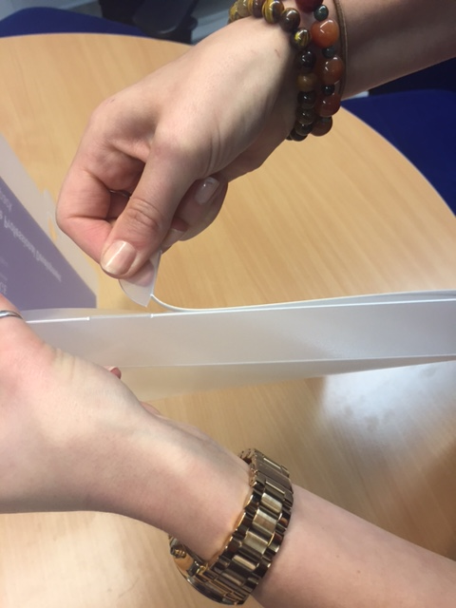
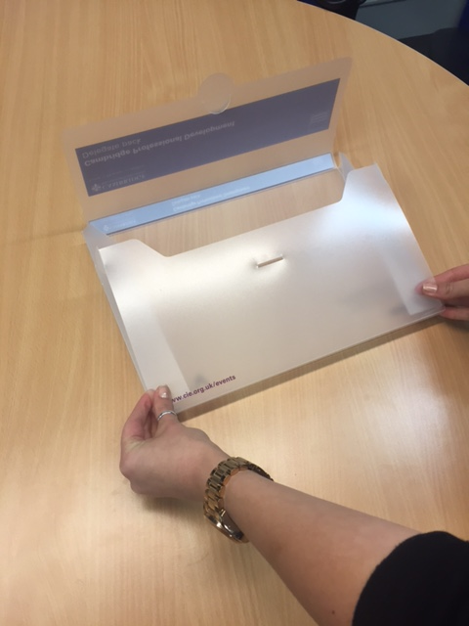
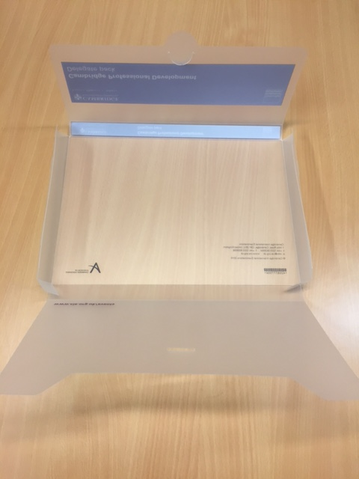

4. 5.
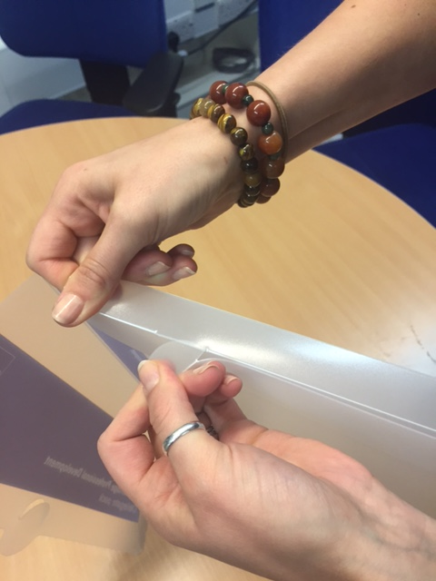
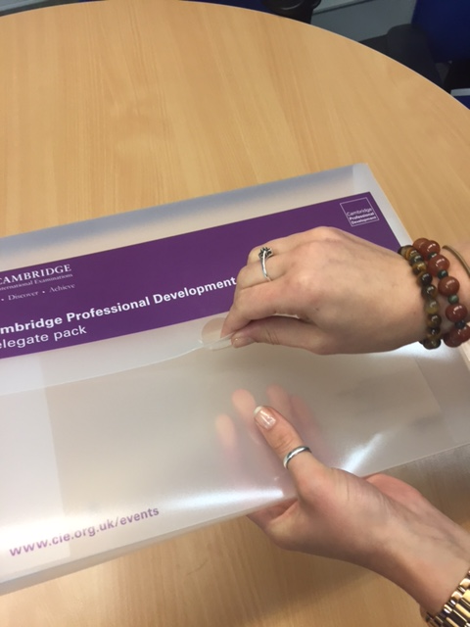

In each delegate folder please place the printed delegate pack documents listed above and one each of the following promotional materials:

- a Cambridge International notebook
- a Cambridge International pen

The training room:

Complete delegate packs should be placed on tables as shown in the photos below.
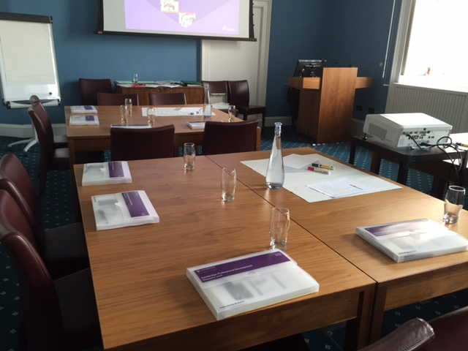
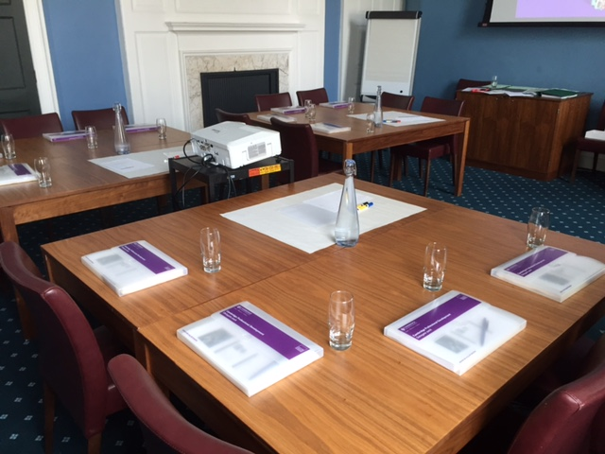
- Tables should be arranged in small groups.
- Drinking water should be available throughout the training days.
- Please also make sure that any other equipment requested by the trainer, such as marker pens, post-it notes and plain paper, is provided.

