
Trainer delivery booklet
Cambridge Professional Development

Cambridge International AS & A Level / IGCSE™ Subject (XXXX)
Introductory level (two-day)
Aims and objectives
- review the syllabus requirements
- explore different teaching strategies
- develop schemes of work
- understand the assessment process
- explore the use of assessment documents to inform teaching

Timetable
The order and timings presented in this pack are suggestions. All activities must be covered, but please feel free to move/extend or shorten activities if you think this would be of benefit to your participants. Also, make sure you check with the Training Events Coordinator or venue if there will be different starting and finishing times.
Day 1
Session number | Suggested duration | Timings | Session title
1 | 20 minutes | 09.00 to 09.20 | Welcome and introduction
2 | 40 minutes | 09.20 to 10.00 | Introduction to the syllabus
3 | 30 minutes | 10.00 to 10.30 | Assessing knowledge
Break | 20 minutes | 10.30 to 10.50
4 | 1 hr 40 min | 10.50 to 12.30 | Formative use of assessment
Lunch | 1 hour | 12.30 to 13.30
5 | 1 hr 30 min | 13.30 to 15.00 | Teaching approaches
Break | 20 minutes | 15.00 to 15.20
6 | 1 hr 30 min | 15.20 to 16.50 | Learning resources and activities
Close | 10 minutes | 16.50 to 17.00

Day 2
Session number | Suggested duration | Timings | Session title
1 | 10 minutes | 09.00 to 09.10 | Welcome back
2 | 2 hours | 09.10 to 11.10 | The assessment
Break | 20 minutes | 11.10 to 11.30
3 | 50 minutes | 11.30 to 12.20 | Using assessment materials
Lunch | 1 hour | 12.20 to 13.20
4 | 1 hour | 13.20 to 14.20 | Long-term planning
Break | 20 minutes | 14.20 to 14.40
5 | 1 hour | 14.40 to 15.40 | Planning your teaching
6 | 10 minutes | 15.40 to 15.50 | Preparing learners for assessment
Close | 10 minutes | 15.50 to 16.00

The documents you will need for each activity are colour-coded to indicate where in the filing system they are found:

Green for materials in the Delegate Pack folder.
Light blue for materials that will be made available for the trainer to distribute during the event. These are filed in the Trainer Desk folder.
Purple for materials in the Trainer Pack folder.

Please note that most of our events now are digital, so some of the materials in the delegate pack will not be printed and the delegates are required to use laptops to access them. Please refer to the digital printing list part A.

Spare copies of these documents will be available on the day in case delegates don’t have access to them.
Day 1[Any thumbnail images that you need to alter will be put into this document from your ppt by Cambridge staff. Please just provide the text.]

Slide | Notes
Session 1 – Welcome and introduction
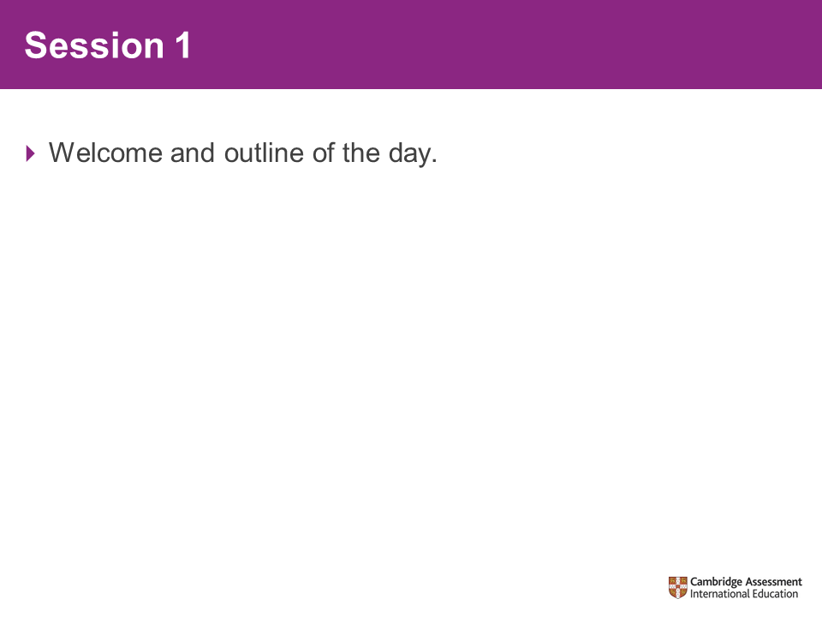 | Welcome participants to the course.  Introduce the course as the Introductory course for XXXX.
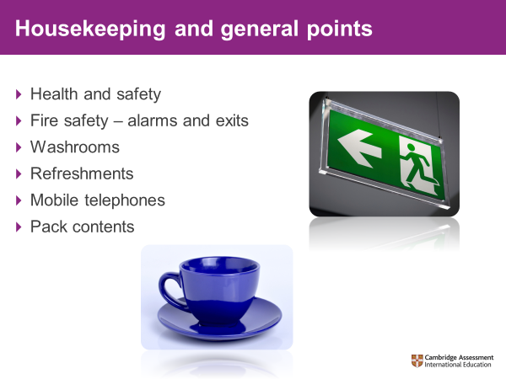 | The trainer should go through each point to ensure all housekeeping details are covered.  Please cover the health and safety procedures for the venue you are in:  Fire Alarms  Check with the venue if there are any planned fire alarms that day and inform the delegates at what time this will be.  If the venue is a school, please advise what type of sound the Fire Alarm is, so the Fire Alarm is not confused with any school bell systems. Inform delegates of the nearest fire exits.  Washrooms  Direct delegates to the nearest washroom facilities.  Breaks and lunch  Explain where tea and coffee for breaks will be and the location for lunch.  Phones  Request that delegates switch their phones off or place on silent if they need to be contactable in an emergency.  Pack Contents  Direct delegates to their packs for the timings and contents for the two days. Additional resources will be handed out as they are needed.
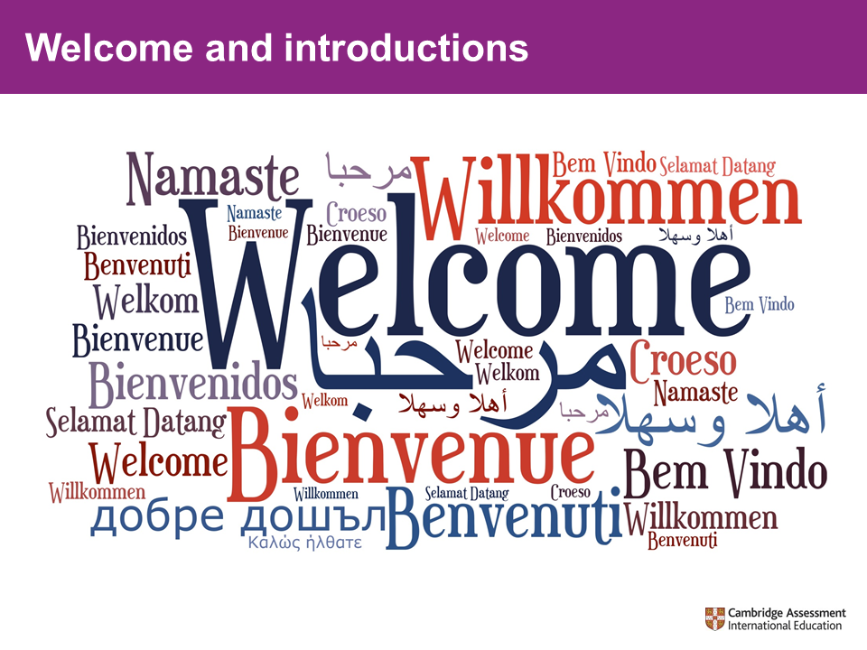 | Welcome and introduce yourself to the participants. Specifically mention teaching experiences, examining work, previous training events you have led. Do not mention publications unless they are endorsed. Highlight your examining experience but if you have sighted live materials from another syllabus, do not mention this.  Trainers often feel awkward ‘singing their own praises’. However, an introduction is important because it establishes your credibility with participants.
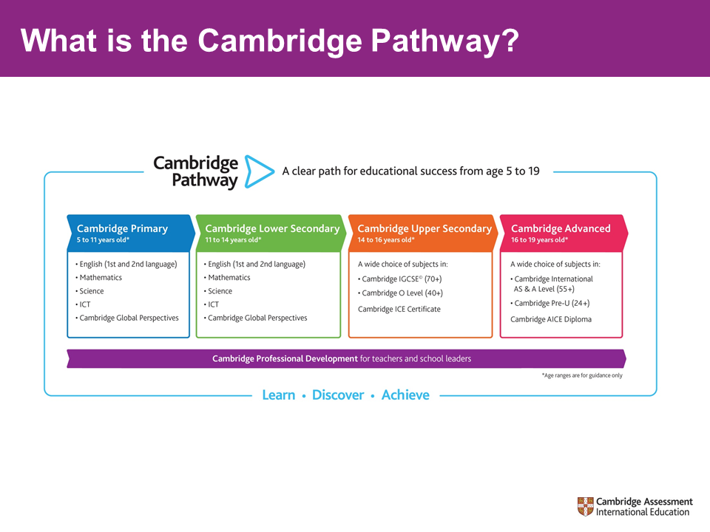 | - This slide is for information so teachers can see the context of the course and how it fits into the wider Cambridge programme:Cambridge programmes and qualifications are carefully designed to engage your learners and give them solid foundations to achieve high levels of academic and personal attainment.  - The programmes are progressive, giving you and your learners a clearly defined path to success from 5 to 19 years. Our four stages lead seamlessly from primary to secondary and pre-university years, and each stage builds on the learners’ development from the previous one.  - We offer flexibility, allowing you to shape Cambridge curricula to the needs and abilities of your learners. You can offer our programmes and qualifications for learners at every stage or focus on specific ones.  Our programmes and qualifications are compatible with other curricula, so schools are free to build a unique curriculum that suits their values with the expertise and support of Cambridge alongside them.
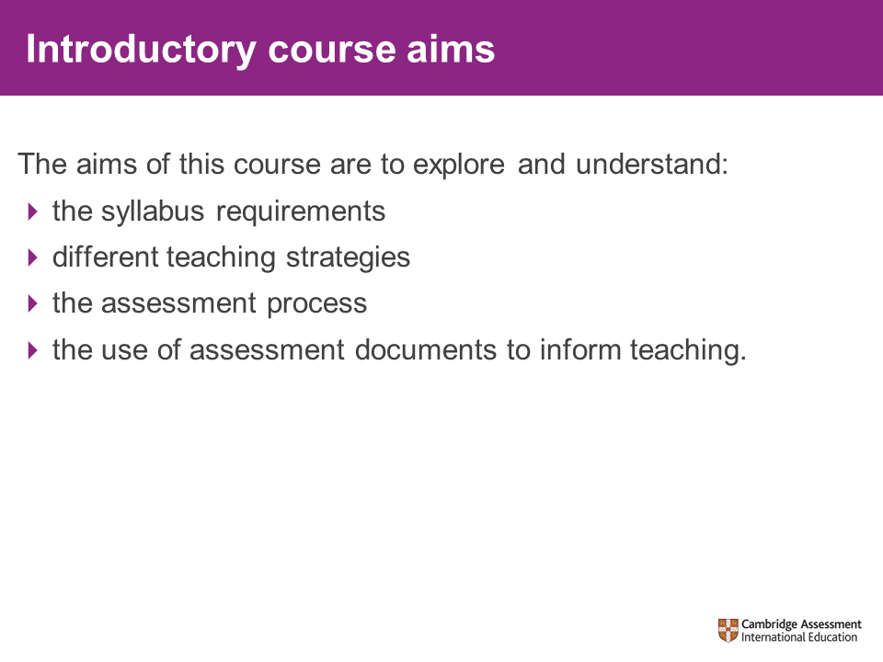 | Show this slide and check that the participants are happy with the outlined content.  Explain that they will have time to ask their own questions and what else they expect from this workshop.
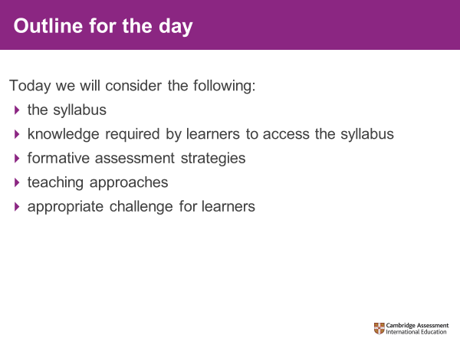
Session 2 – the syllabus
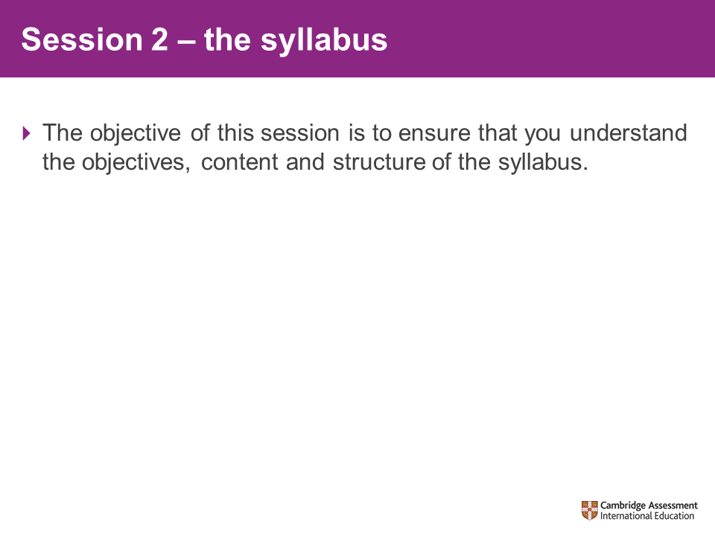 | Ask participants to find the syllabus document from their Delegate Packs.
Activity 1 – quiz
Resources needed:  - the syllabus  XXXX_I2_Syllabus_  XXXX-XX  - the quiz  XXXX_I2_Quiz  - trainer answers  XXXX_I2_Answers  Approximate time to complete:  - 25 minutes |  | Hand out copies of the Quiz, ask participants to complete Activity 1.
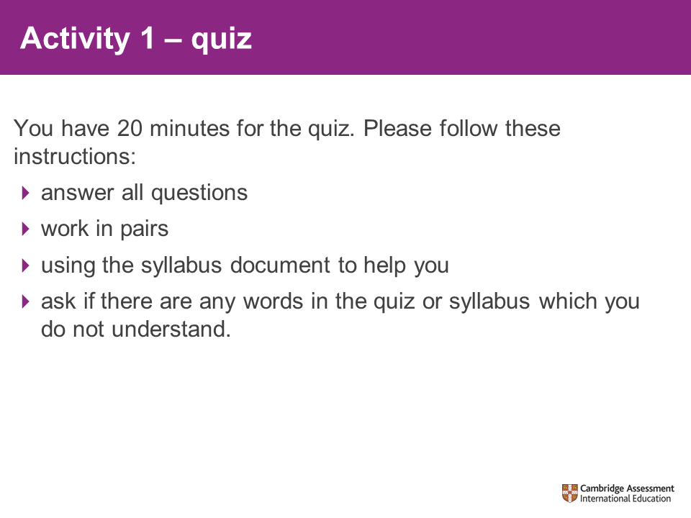
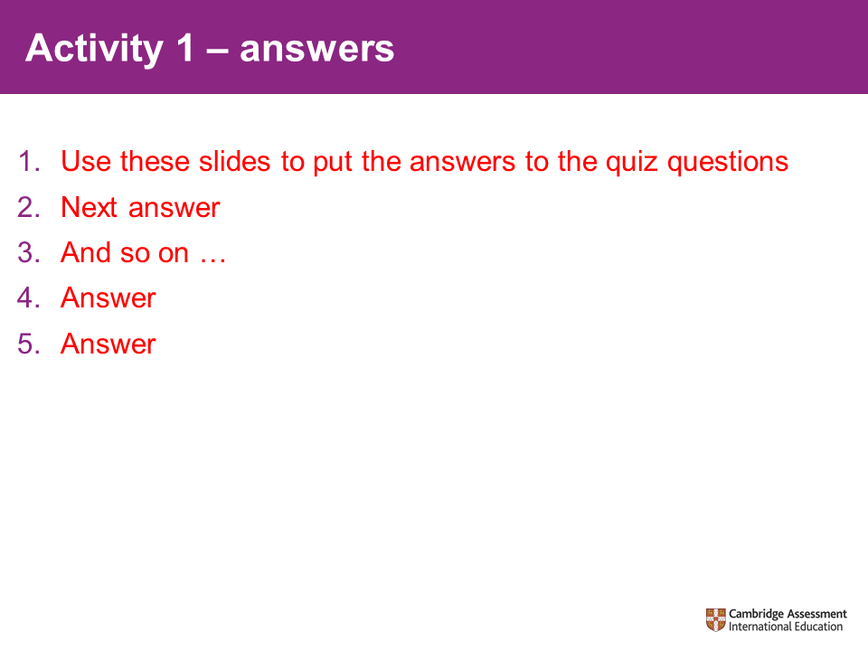 |  | These slides take you through the answers of the quiz.  Show these to participants and discuss as necessary.  Pack writer:  Add slides here to take participants through the answers of the quiz.  Do not put lots of information on the slides – put this on the answer sheet so they can be discussed if necessary.  Include guidance on the quiz answer sheet so that the trainer has the key points that should be utilised when directing the participants to look at the syllabus document.
You may wish to include additional slides to show key aspects of the syllabus, for example potential combinations of units.

Please do not cover syllabus changes since this is Introductory course and we do not expect teachers to have seen/taught previous versions.

Be aware of the changes if questions are asked, but this should not be added to any slides or be the focus of the workshop.

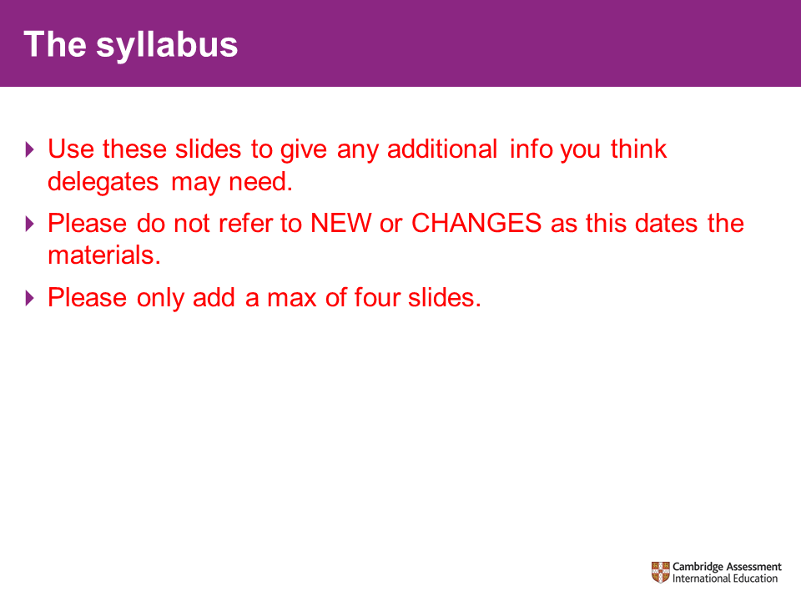
Session 3 – assessing knowledge
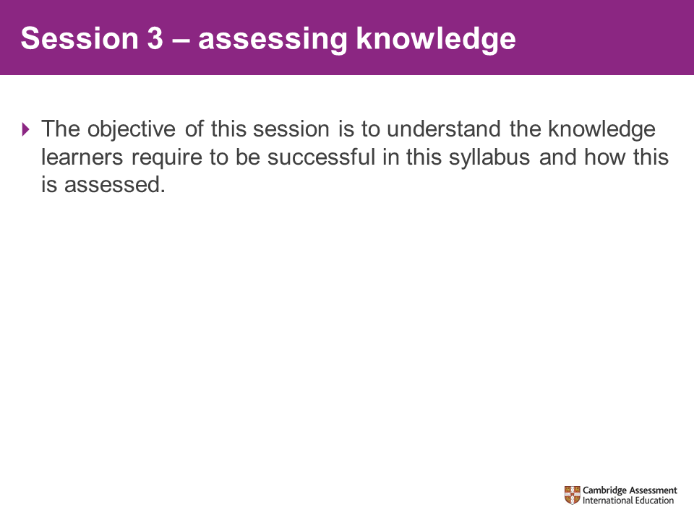 |  | The aim of this session is to help teachers to identify required underpinning knowledge and how this might be assessed.
Activity 2 – knowledge and skills
Resources needed:  - the syllabus  XXXX_I2_Syllabus_  XXXX-XX  - Knowledge/skills cards  XXXX_I2_Card  Activity  Approximate time to complete:  - 25 minutes |  | Introduce Activity 2 – knowledge and skills.  Participants will sort the cards according to how essential that area of knowledge is for the section of the syllabus selected. Some blank cards are included in case participants wish to add their own ideas.  Once participants have completed the task on their table (please set time limit for this), they can go around the room and see/discuss how other groups ranked the underpinning knowledge/skills.  Pack writer:  Select a section of the syllabus and identify the required underpinning knowledge/skills from previous learning for this.  Input the underpinning knowledge/skills into the card templates.  Create the underpinning knowledge/skills list for both the trainer to use and participants to take away.
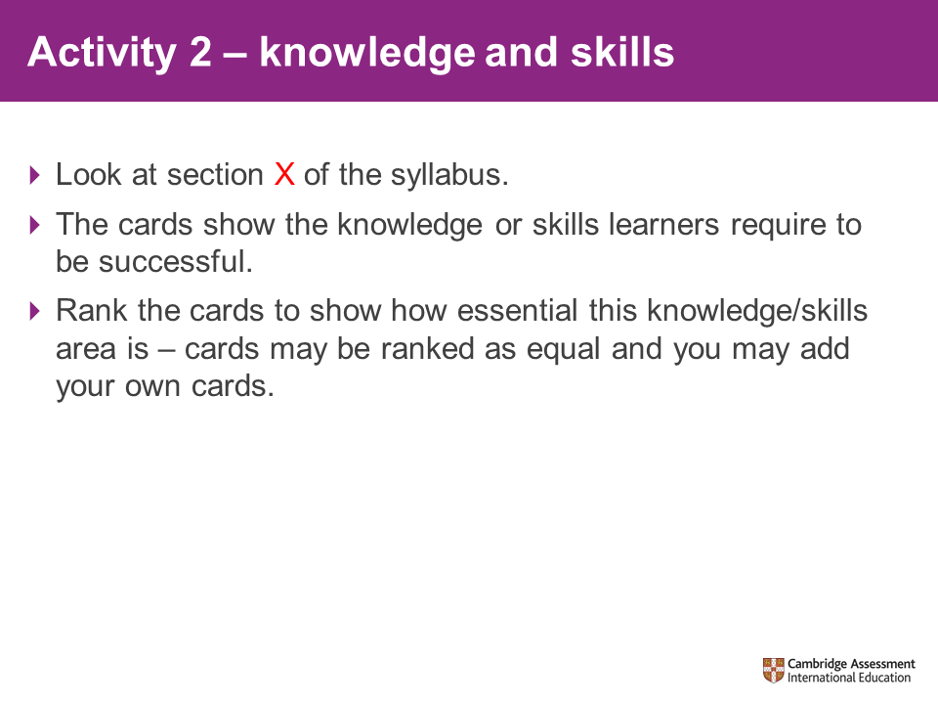
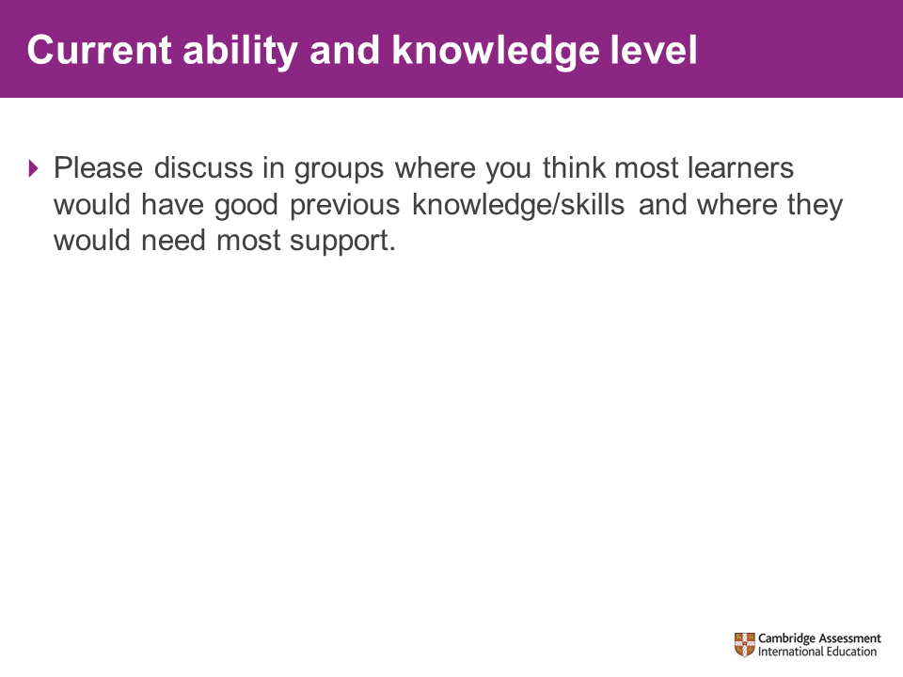 |  | Give the participants 10 minutes to consider/discuss which of the underpinning knowledge/skills that their learners already have and those that may require development.
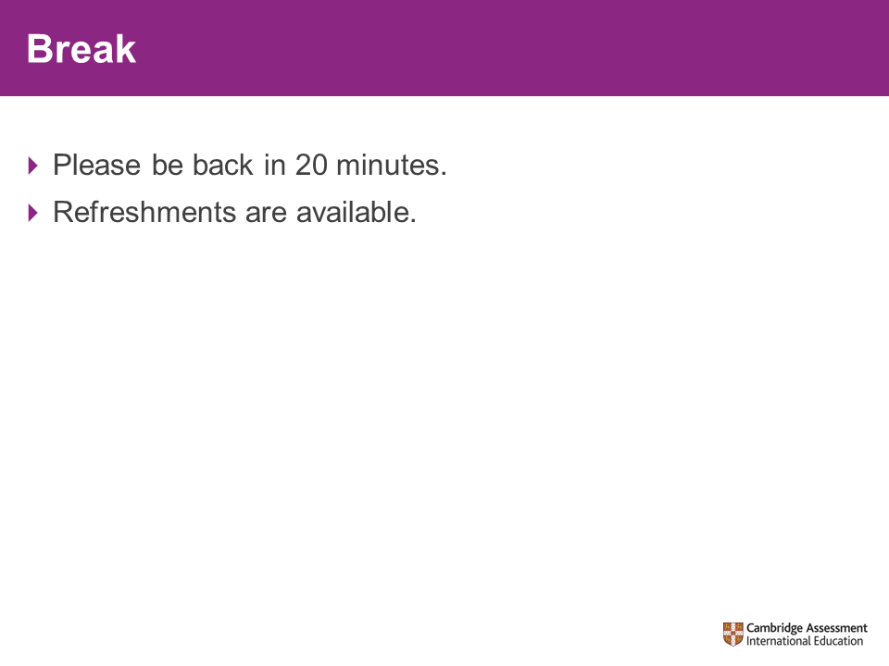 |  | 20-minute break  Emphasise the importance of returning punctually.

Session 4 – formative uses of assessment
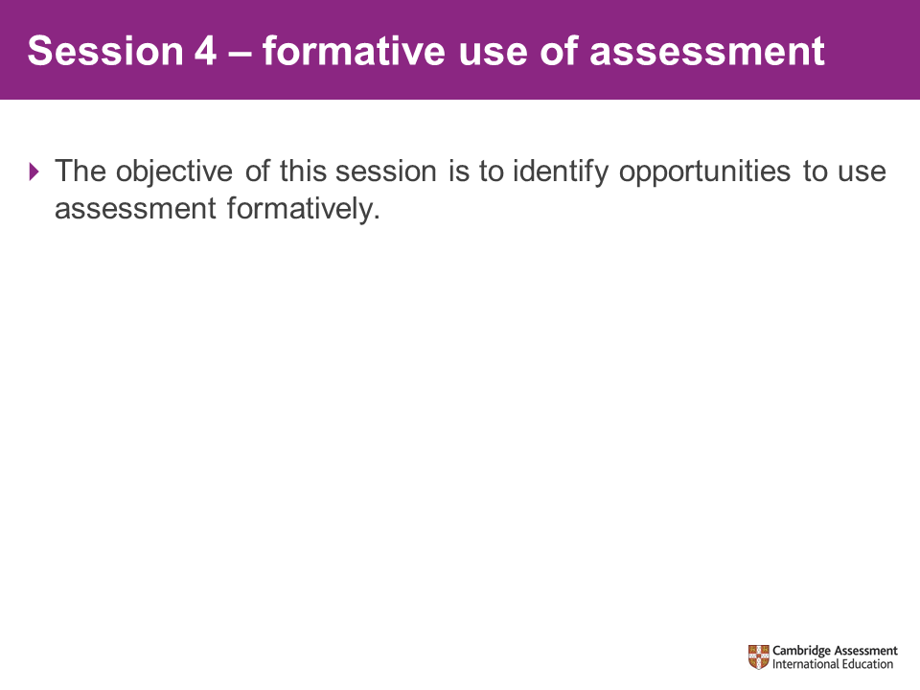 |  | In this session, participants will have the opportunity to discuss and plan strategies to ensure that they can use assessment formatively.
Activity 3 – formative uses of assessment
Resources needed:  - The syllabus  XXXX_I2_Syllabus_  XXXX-XX  - Example assessment  XXXX_I2_Form_  Assess  Approximate time to complete:  - 1 hour 30 minutes |  | Ask participants to consider an area of the syllabus that they believe their learners require support – this can be from the knowledge/skills identified in the cards activity before the break. Participants will be creating an assessment to use formatively for this area.  If necessary, please start by explaining what is meant by formative use of assessment.  Participants should work in groups to prepare an assessment that could be used formatively for the section of the syllabus that they have identified. Their assessment should:  - focus on assessing the skills or knowledge required for this part of the syllabus  - identify learners’ level of understanding of the concepts or skills  - be accessible – the assessment will not tell you anything if the learners cannot access it  - allow learners to apply their knowledge.  If participants are struggling to start, you may use the example assessment which is included in the trainer materials to prompt/support them as you feel necessary. Otherwise, this can be handed out at the end of the activity as an example for them to take home.  Pack writer:  You should include an exemplar assessment for participants to look at.  You should also include some suggested questions, activities and feedback techniques that could be used formatively.
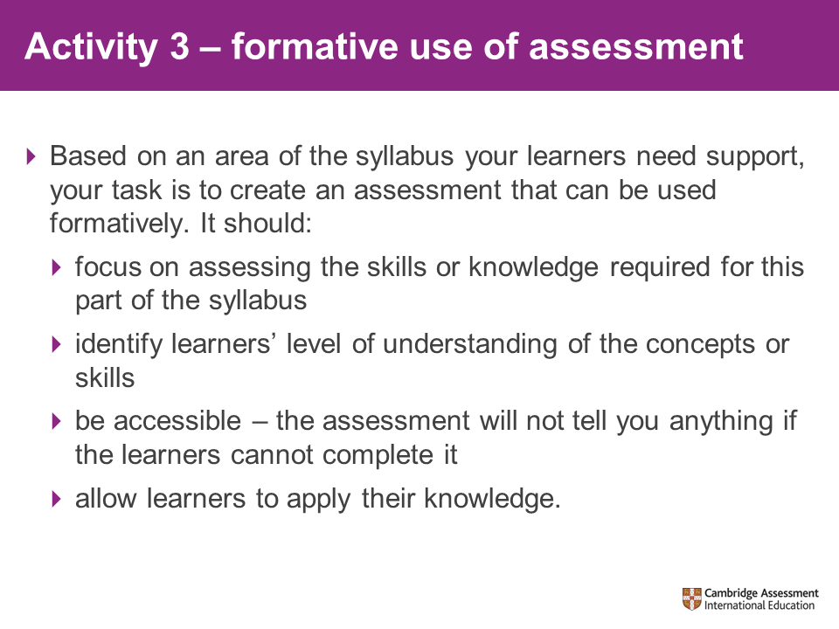
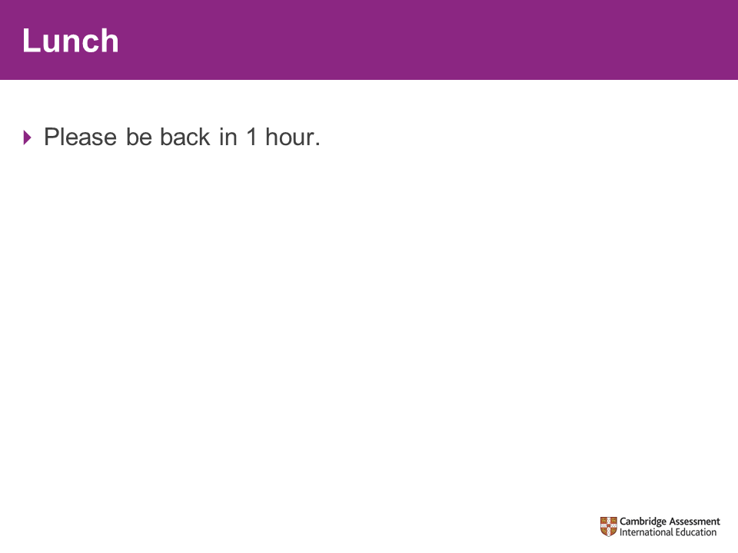 |  | 1-hour lunch  Emphasise the importance of returning punctually.
Session 5 – teaching approaches
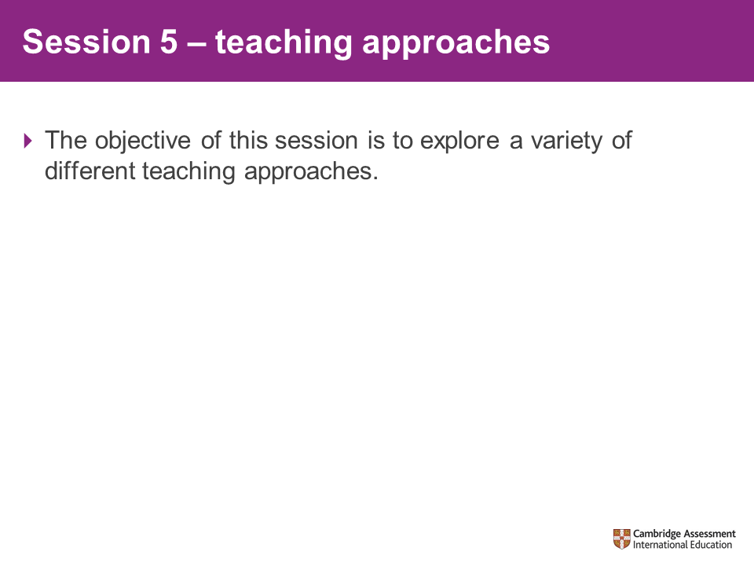 |  | Explain that this session will look at some different approaches to teaching and that the next session will look at some examples of activities and resources that might be used in teaching.
Activity 4 – teaching resources
Resources needed:  - Teaching approach handouts  XXXX_Tapproaches  _tables  XXXX_Tapproaches  _HO  - KASH analysis  XXXX_KASH  analysis  Approximate time to complete:  - 70 minutes + 20- minute feedback |  | Each table will be given a printout of a slide describing a teaching approach. The groups (tables) should discuss the teaching approach and develop an activity using this approach to deliver an area of the subject. This might be a single lesson or series of lessons.  Groups will be presenting the approaches together with their example of how this might be used at the end of this session.  It is important to emphasise that the groups are not trying out this approach themselves in the session, but instead are planning how to use it in their teaching.  Groups should also complete a KASH analysis for their allocated teaching approach and include this as part of their feedback to the room (feedback should be about 20 mins in addition to the 70-minute activity time).
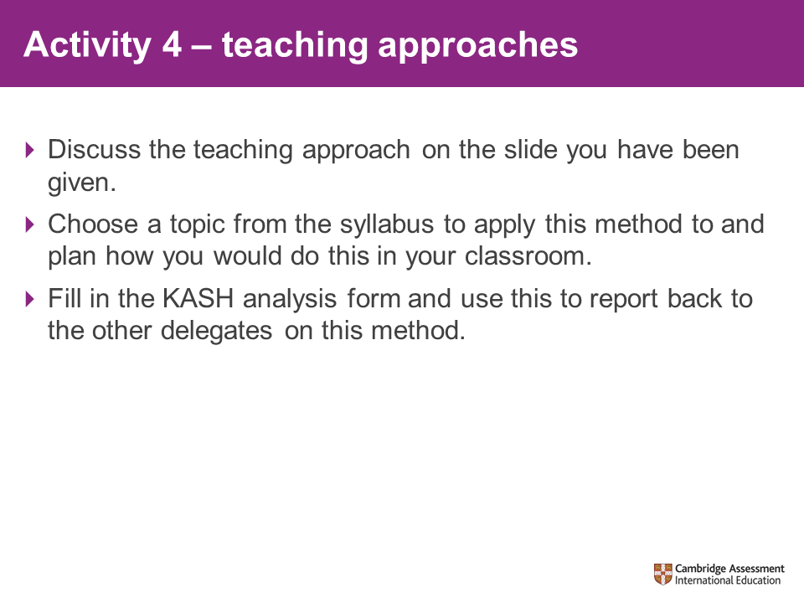
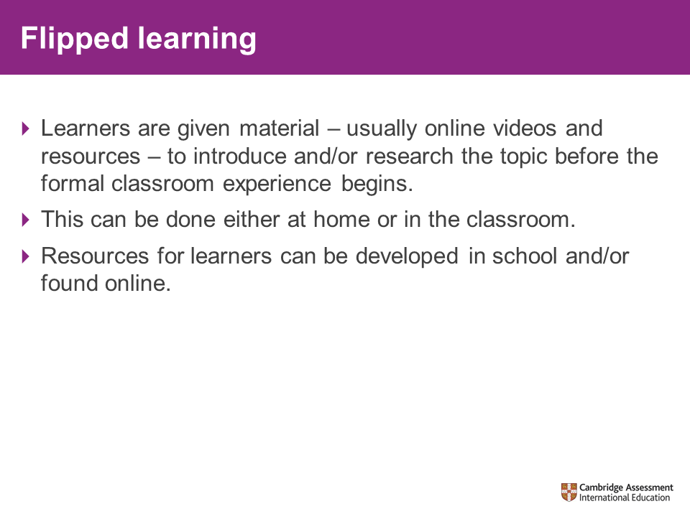  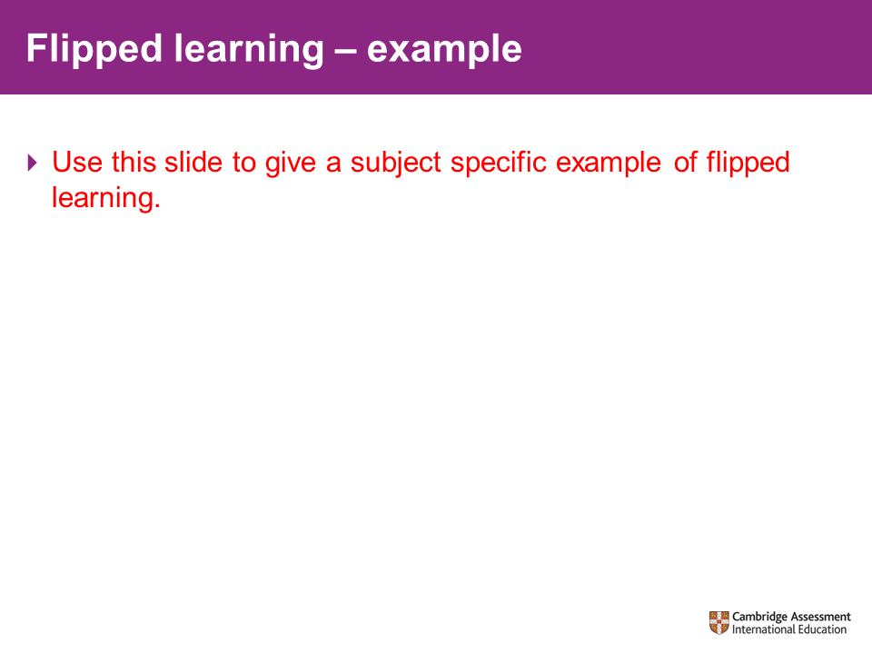 |  | Pack writer: adapt the example in red text to your subject or replace with an example of how flipped learning might be used in your subject. Examples are not needed for the other approaches and would reduce the opportunity for participants to discuss the application of each within the subject.  Here is an example for flipped learning:  Setting a homework for a group of learners to use YouTube to search for A Midsummer Night’s Dream Act 3 Scene 1 and watch a couple of different versions (this might include making notes). The start of the next lesson will be to discuss the scene in groups. The learners could then RAG rate how well they completed the homework.
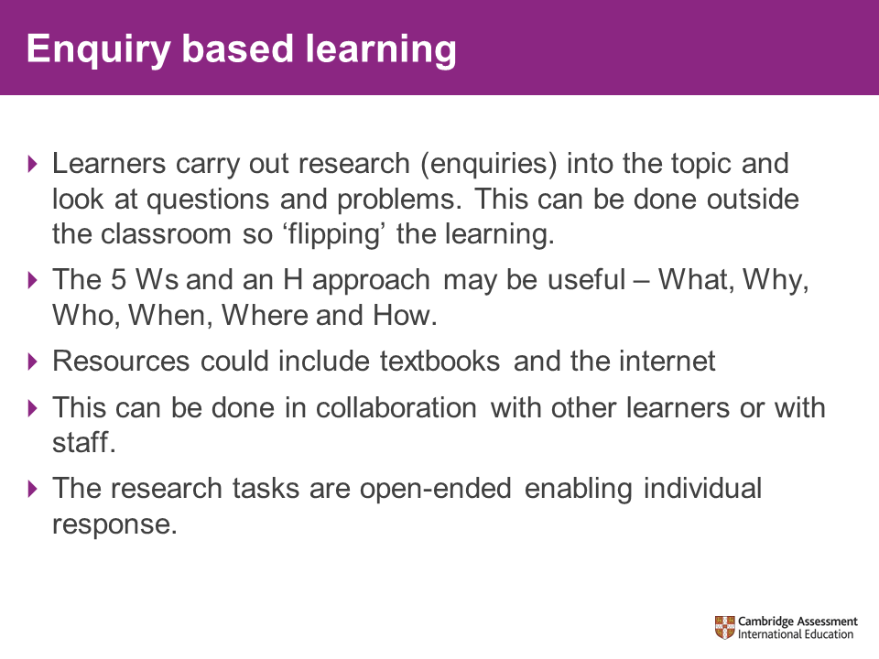 |  | 5 W’s and an H can be used as a prompt for learners to create the questions that they want to answer in their enquiry (see slide for details).
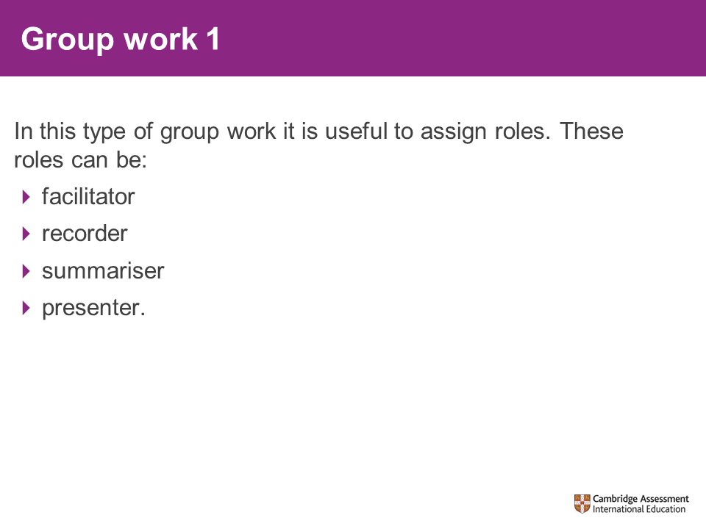 |  | Taking roles in a group encourages learners to think about an issue in a particular way. It also encourages participation as learners have to fulfil a specific function.
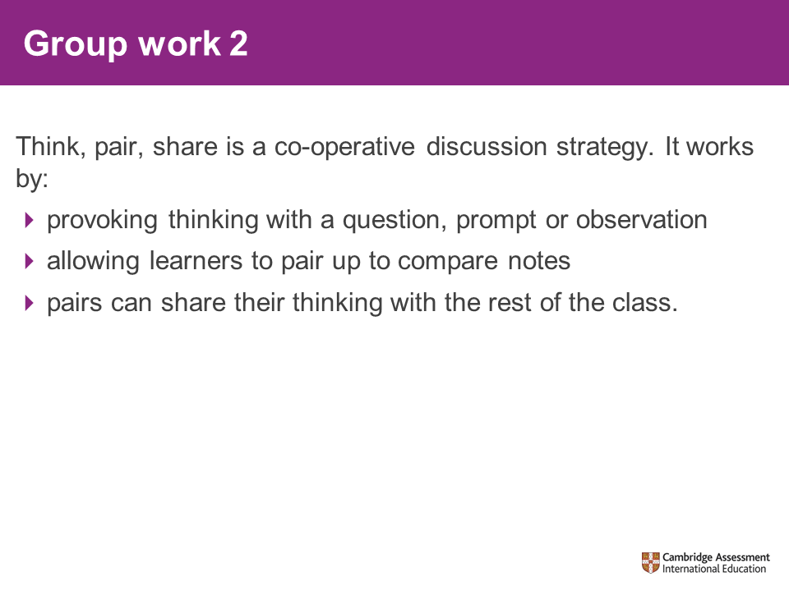 |  | This is a cooperative discussion strategy. The three steps describe what the learners are doing at each stage.  - Think – provoke learners thinking with a question, a prompt or an observation. Learners spend a few moments thinking about the question. This builds in wait time where learners get to think about their answers. This silent thinking time eliminates the issue of learners who shout out the answer before others have the chance to think about it and ensures everyone is engaged with thinking about the question.  - Pair – learners pair up with designated partners and discuss their ideas. They can try to identify the answer that they think is the best, the most convincing, the most unique etc.  - Share – ask the pairs to share their thinking, this could be going around each pair in turn or asking for hands up.  Think-pair-share is helpful because it structures the discussion.  Snowballing is a variation on think-pair-share where the groups are built up in a greater number of steps – individual, then pair, then two pairs, then two groups, then the whole class.
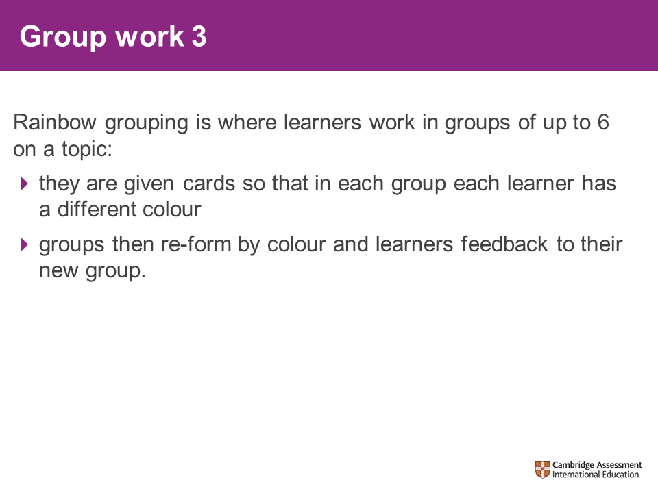 |  | This slide explains rainbow grouping.
20-minute break
Emphasise the importance of returning punctually.
Session 6 – resources and activities
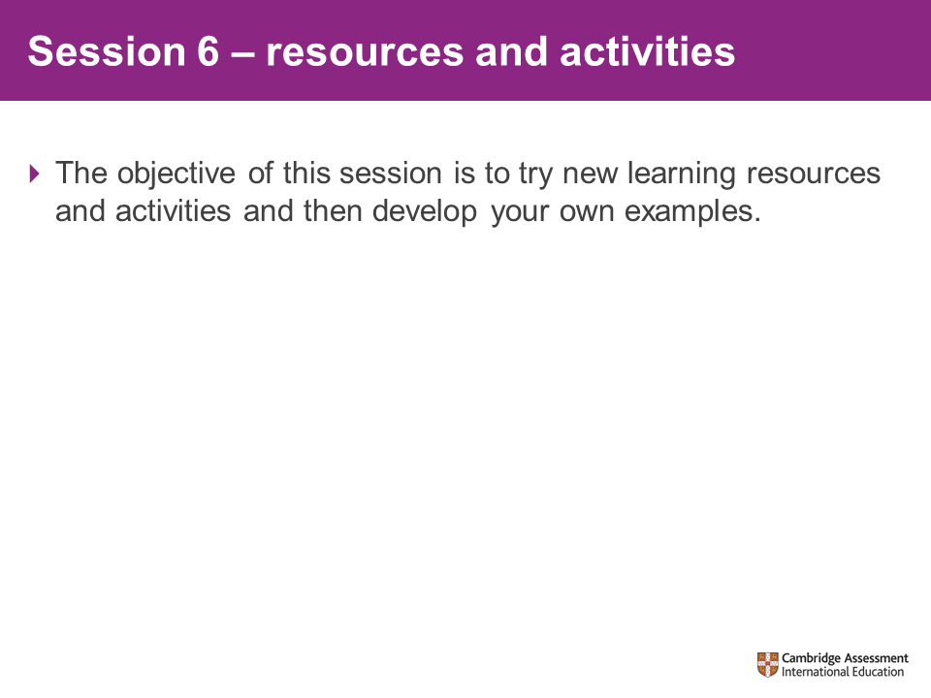 |  | We will look at some examples of learning resources and activities. Participants will have the opportunity to try out some of these , to evaluate the examples we have given them and to develop some of their own.
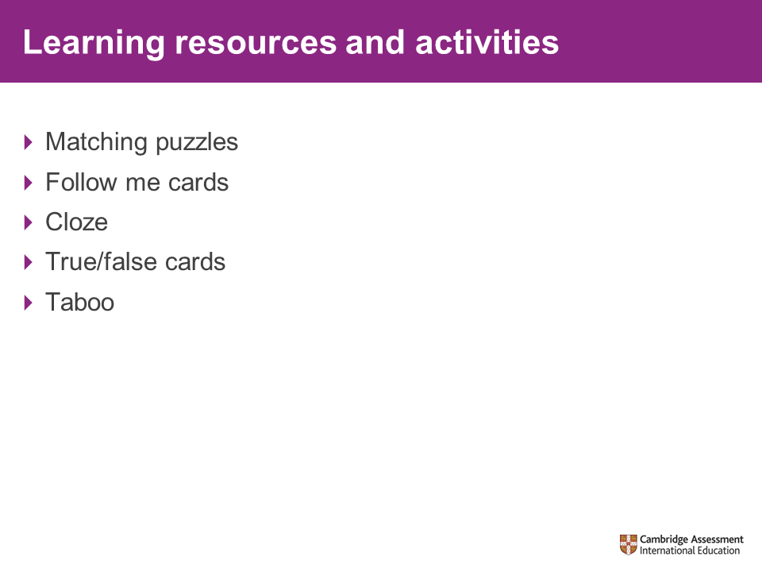 |  | Matching puzzles  Learners match key terms and their definitions.  Follow-me cards  The question cards are shared between the learners in the group. They don’t all have to have an equal number of cards.  One learner will volunteer to go first and will ask the question on the bottom of one of their cards. The other learners will need to look for the answer to that question at the top of one of their cards. They will give that answer from that card. As long as this is correct (the others should agree!) then the question from the bottom of that card should be read out.  The other learners will again look for the answer and shout it out if they have it. They then read out the question from that card.  The sequence continues until you get back to the first card.  Cloze  This involves filling the gaps in the statements.  A useful plenary activity which creates a summary of a lesson or topic.  True/false cards  Learners should sort the statements into true or false.  It is important to choose statements which will lead to a rich debate.  Taboo  A learner is given a card with a key word relating to the topic being studied. There is also a list of taboo words.  The learner needs to describe the key word to the others in the group without using the key word or taboo words in their explanation.  Differentiation can be achieved by allowing learners to use, for example, one taboo word from the card.
Activity 5 – trying out activities
Resources needed:  - Cloze passage  XXXX_I2_Cloze  - Follow me cards  XXXX_I2_Follow  me  - True/False activity  XXXX_I2_True  False  - Taboo  XXXX_I2_Taboo  - Matching puzzle  XXXX_I2_Matching  Approximate time to complete:  - 50 minutes | Direct the participants to investigate the examples of the activities we have just outlined using the sets of resources provided on each table.  Participants should discuss how these activities could be used in their classroom.  Encourage participants to consider how one or more of the activities might be used for formative assessment for a topic of their choice.  Please note:  The card activities (matching puzzle, taboo and follow me) are not presented in a format so that participants can complete them as learners would. The emphasis is the discussion about how to use the activities in their classes, rather than completing the activity themselves.
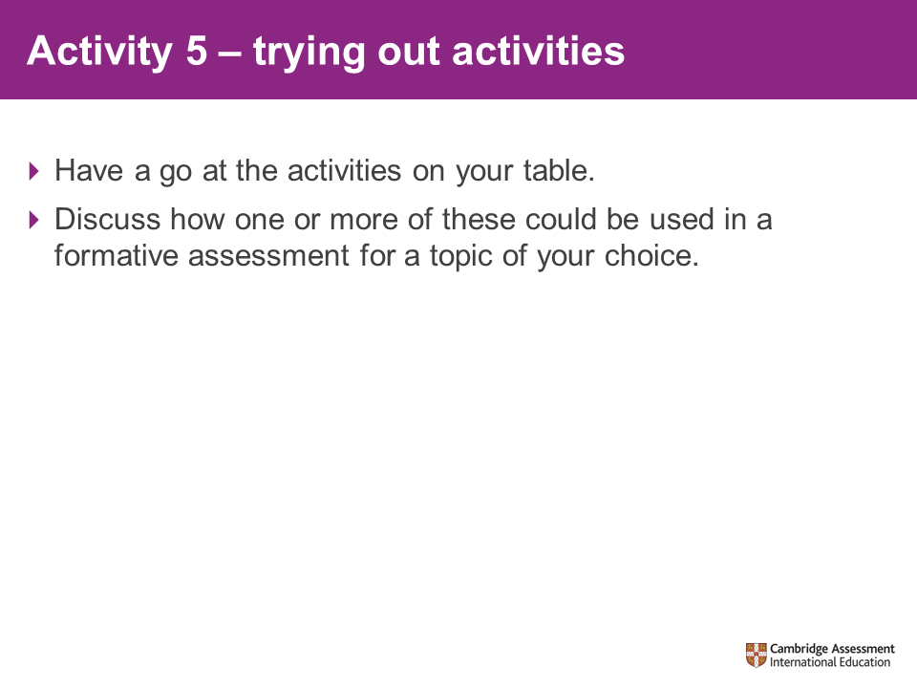
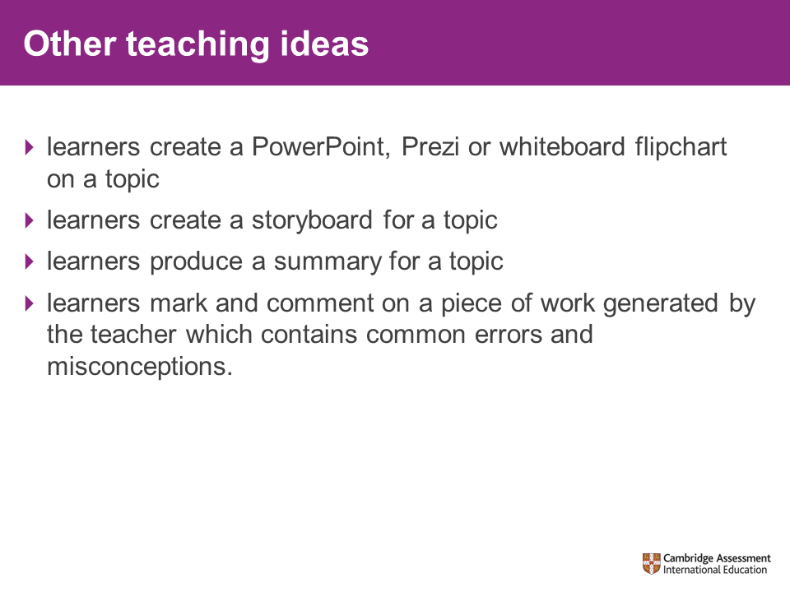 | Learners mark and feed back on a piece of work:  - The teacher creates a piece of work with errors or selects an anonymised piece of work. The class then marks and feeds back on this, identifying the errors and what they would do to improve.
 | The School Support Hub contains 30,000 high-quality teaching and learning resources. Resources are updated and new content is added regularly.  All teachers who deliver Cambridge Upper Secondary and Cambridge Advanced stages should have access to the School Support Hub. To get access, participants should speak to their school support coordinator who can set up an account for them. If participants do not know who their School Support Coordinator is, they should contact Cambridge International customer services who will be able to tell them (info@cambridgeinternational.org)  To log in to the School Support Hub visit www.cambridgeinternational.org/support
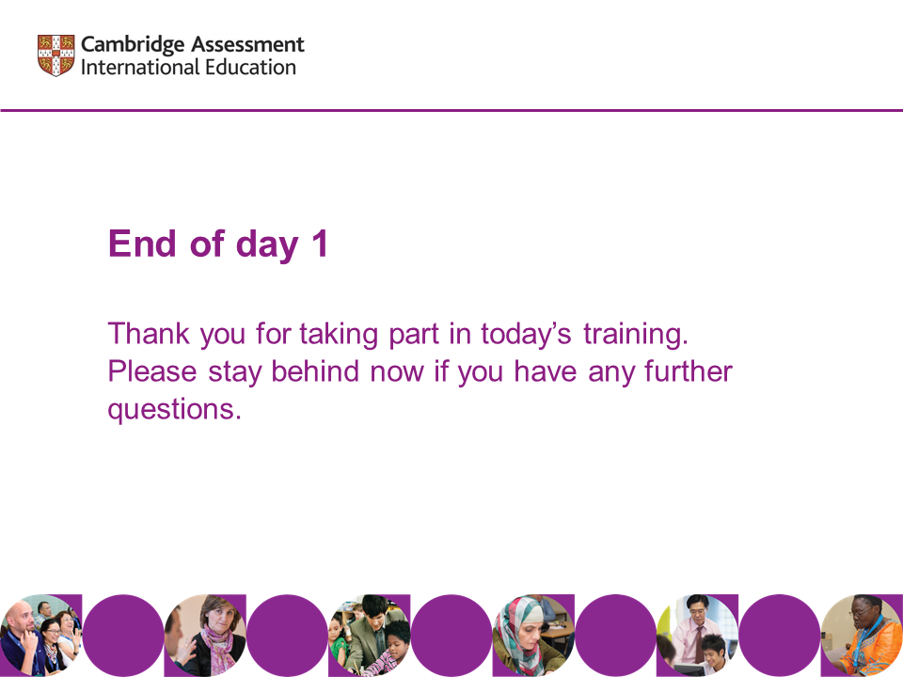 | Thank the participants for taking part in today’s training.  Remind participants of the start time and location for Day 2.  Indicate that you will be around for a few minutes if any of them wish to ask any questions.

Day 2

Slide |  |  |  | Notes
Session 1 – welcome and outline of the day
 |  |  | Welcome participants to Day 2 of the Introductory course for syllabus XXXX.
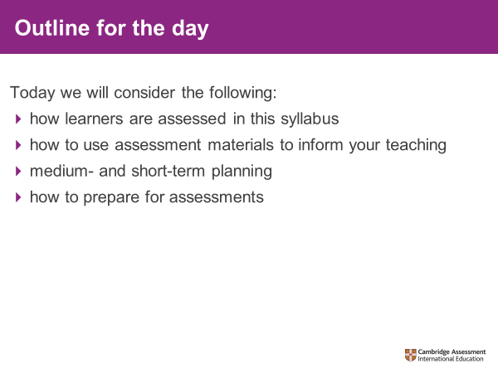
Session 2 – the assessment
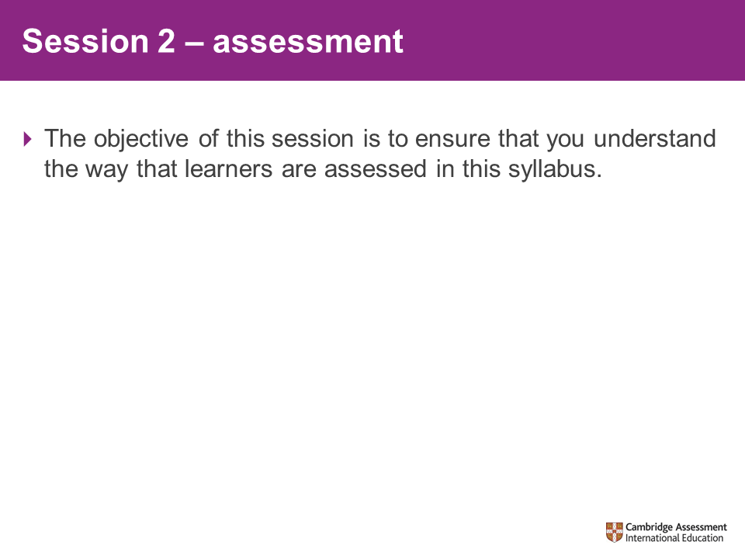 |  |  | Explain to participants that we are going to look at the marking of exam scripts and coursework (delete if not appropriate) for this syllabus.
Activity 6 – marking candidate scripts
Resources needed:  - Scripts  XXXX_I2_PaperX_ScriptX  - Mark schemes  XXXX_I2_P1_MS  - Inserts/Question papers  Approximate time to complete:  - 90 minutes |  |  | Ask participants to use the mark scheme(s) provided to mark the exemplar scripts.  You may wish to briefly go over the mark schemes with them before they start.  The scripts used for this marking activity may not be from the most recent series, but they will align with the assessment structure and criteria. The reason for this is that this activity is not meant to be a review of the series, but an opportunity for participants to extend their understanding of the assessment of the skills and knowledge required and of the application of the mark scheme.
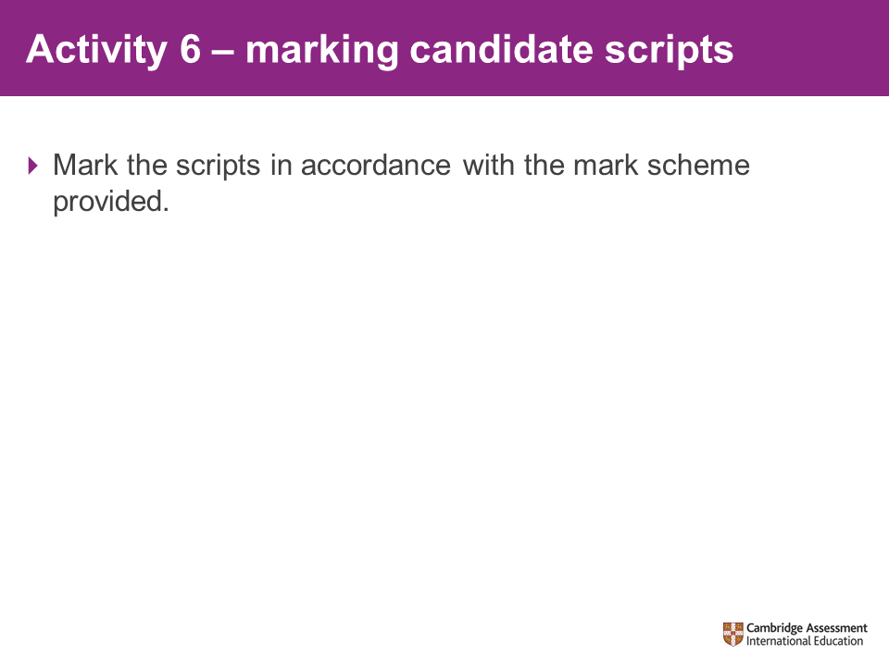
Resources required:  - Marking feedback  XXXX_I2_Marking  _Feedback  Approximate time to complete:  - 30 minutes |  | Review the marking of each script using the marking feedback provided.  Pack writer: you will need to create a handout which provides feedback on the marking. This should be suitable for both the trainer and participants to use.  Please refer to your brief for further instructions, including the number of scripts you are required to choose and feed back on.
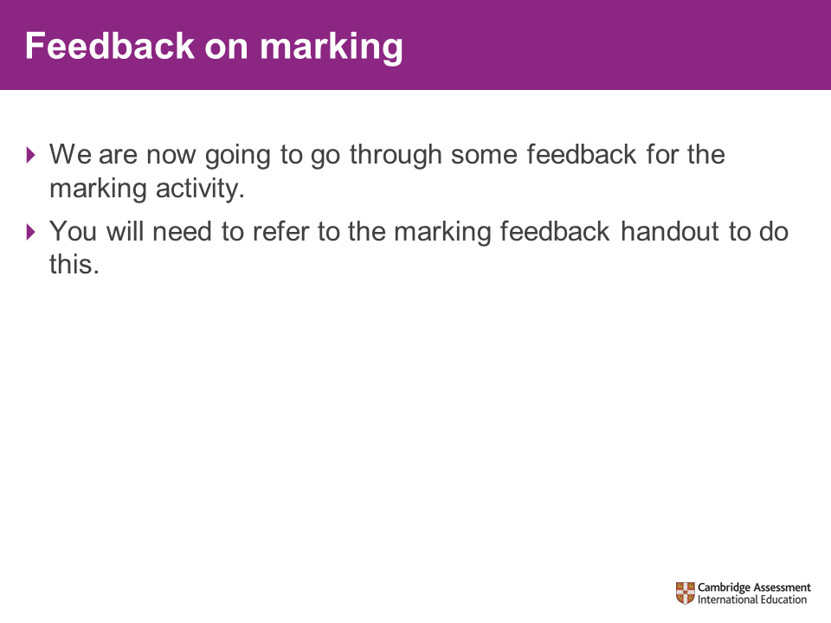
20-minute break
Emphasise the importance of returning punctually.
Session 3 – using assessment materials
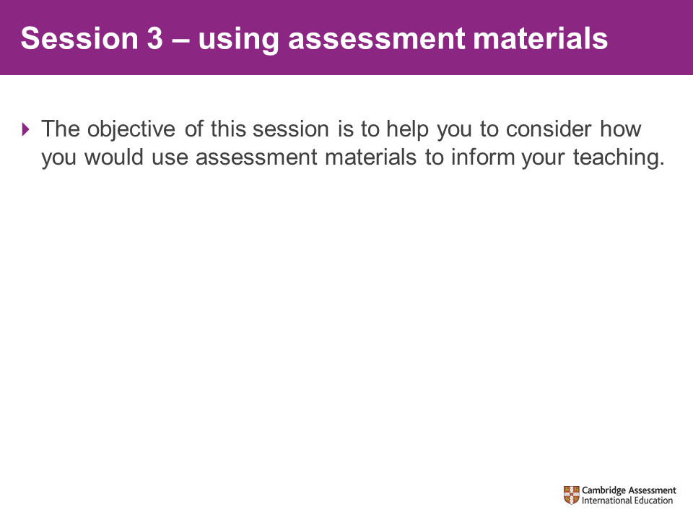 |  | Explain that past assessment can be a valuable resource for teaching. You can use them to:  - formatively assess learner progress  - increase learner familiarisation with the assessment  - help learners to understand the requirements of the mark scheme.
Activity 7 – analysing reports
Resources needed:  - Key messages  XXXX_I2_Key_  PERT  Approximate time to complete:  - 15 minutes + 10- minute feedback |  | Ask participants to look through the key messages from the Principal Examiner Reports provided in their packs.  Pack writer, you will need to create this document, it should effectively summarise the common errors identified throughout the PERT. For example, how do candidates repeatedly get a particular type of question wrong? Where do they generally miss the opportunity to obtain higher marks on particular types of question and why? You may also want to include anything in your experience it would be useful for participants to know.  Participants to refer to Key Messages handout and consider the implications of these in their classrooms. They should make notes for discussion. How might the issues be addressed?  Ask participants to feed back points they found the most interesting/relevant to their own classroom setting.
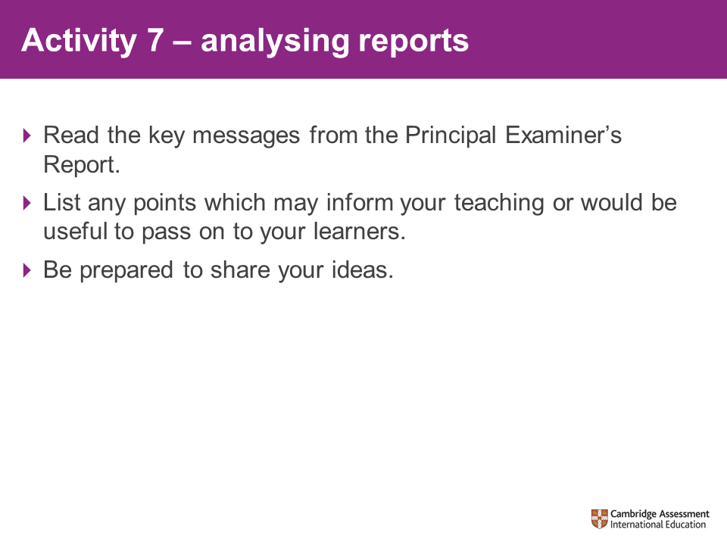
Activity 8 – past paper materials
Approximate time to complete:  - 10 minutes + 5-minute feedback | Ask participants to think of ways that they could use past paper materials within the classroom.  Give them 10 minutes to come up with as many ideas as possible.  Ask for feedback from each table.
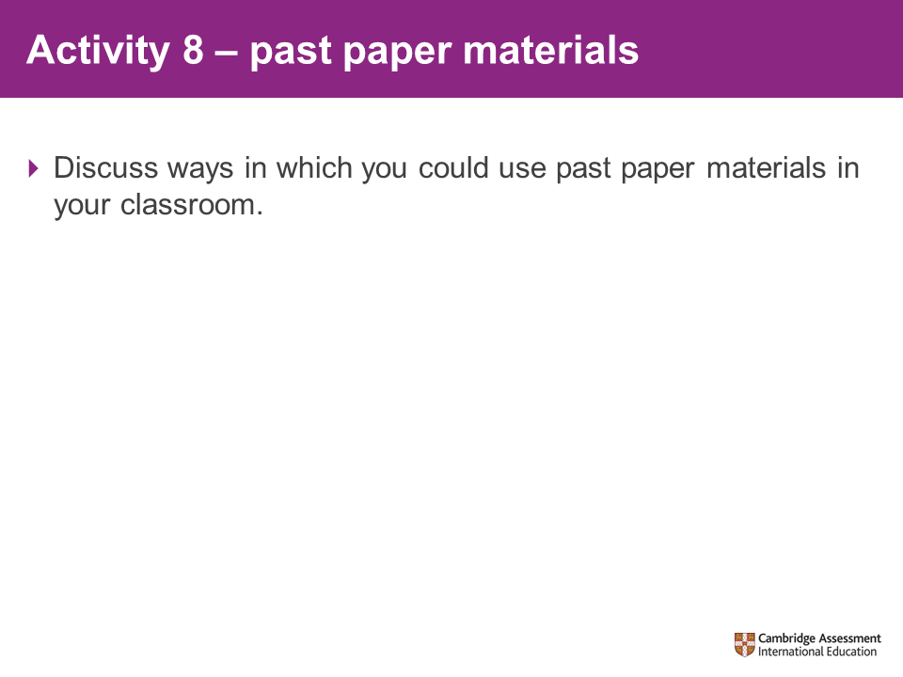
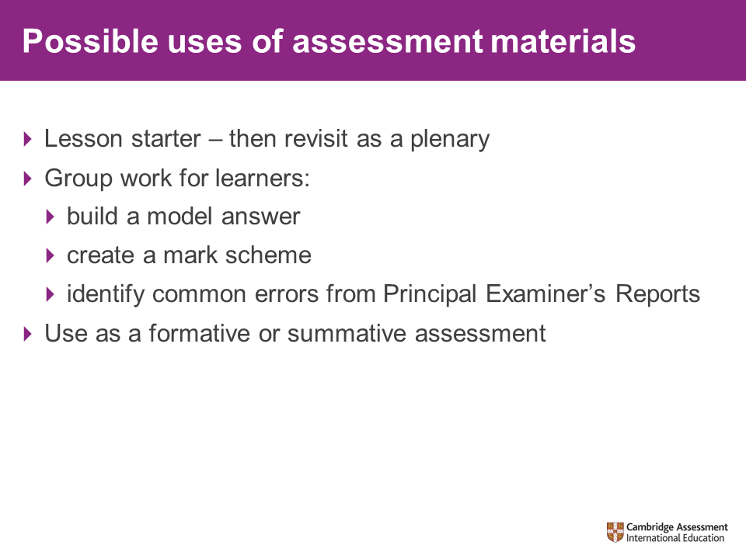 | Exam papers can be used in many ways in the classroom, for example:  - As a starter question – how much of this question can you do now? You can then revisit this at the end of the lesson as the plenary.  - For learners to create a model answer for the question either as a group or individually (timed or untimed).  - For learners to create a mark scheme for the question (which will involve them thinking through the question).  - Learners can mark exemplar answers using the mark scheme and/or their own or other learners’ work.  - Learners can look at the Principal Examiner’s Reports and identify common errors.  - As an assessment of a section of work – either formatively assessing progress or summatively at the end of a unit. This could lead to learners Red, Amber, Green (RAG) rating themselves on a topic list and then working to address areas of weakness before revisiting a very similar question.
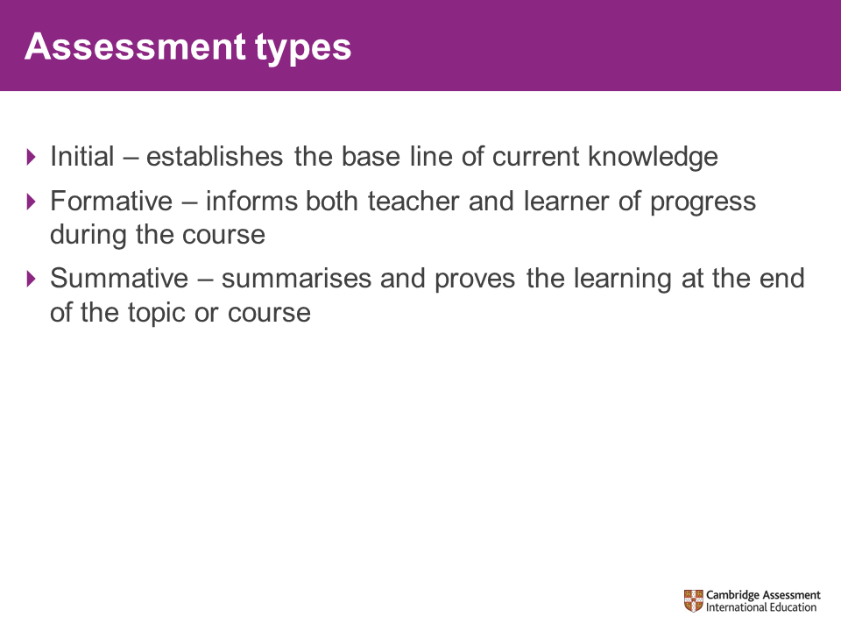 | Yesterday we discussed formative assessment and we have just referred to initial, formative and summative types of assessment. Here is a brief explanation of these three types.
1-hour lunch
Emphasise the importance of returning punctually.
Session 4 – long-term planning
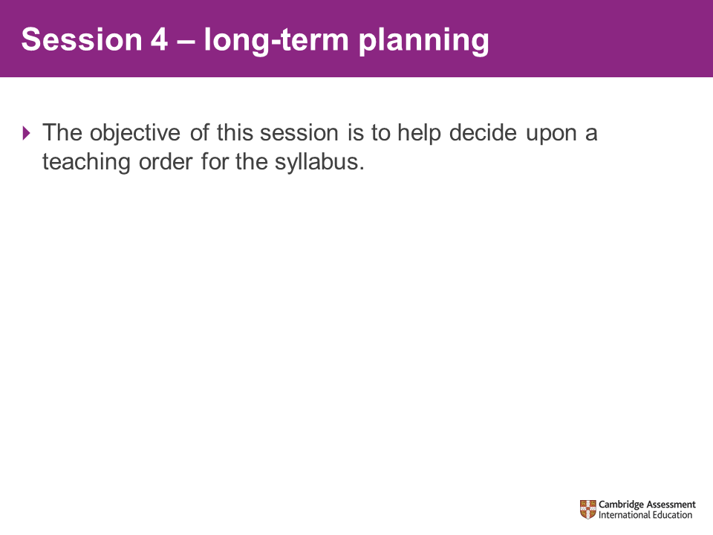 | Share the objective with participants.
Activity 9 – interdependent units
Resources needed:  - Syllabus  XXXX_I2_Syllabus_  XXXX-XX  Approximate time to complete:  - 30 minutes + 15-min feedback | Explain that we are going to consider the order in which sections of the syllabus are delivered. To do this we will be looking at where one section of the syllabus relies upon knowledge/skills from another section.  Ask participants to identify examples of inter-dependent areas of the syllabus.  .  Ask participants to feed back to the group on their findings (this should take approximately 15 minutes in addition to the 30 minutes they have spent working in their groups).  Highlight to participants that these interdependencies will restrict the order in which you can deliver the sections of the syllabus.  Pack writer: If your syllabus requires centres to complete coursework OR write tasks and complete coursework, then this can be included at this point as it will build into the sequencing of teaching. Add slides and trainer notes here as appropriate, being as succinct as possible to keep slide numbers to a minimum.
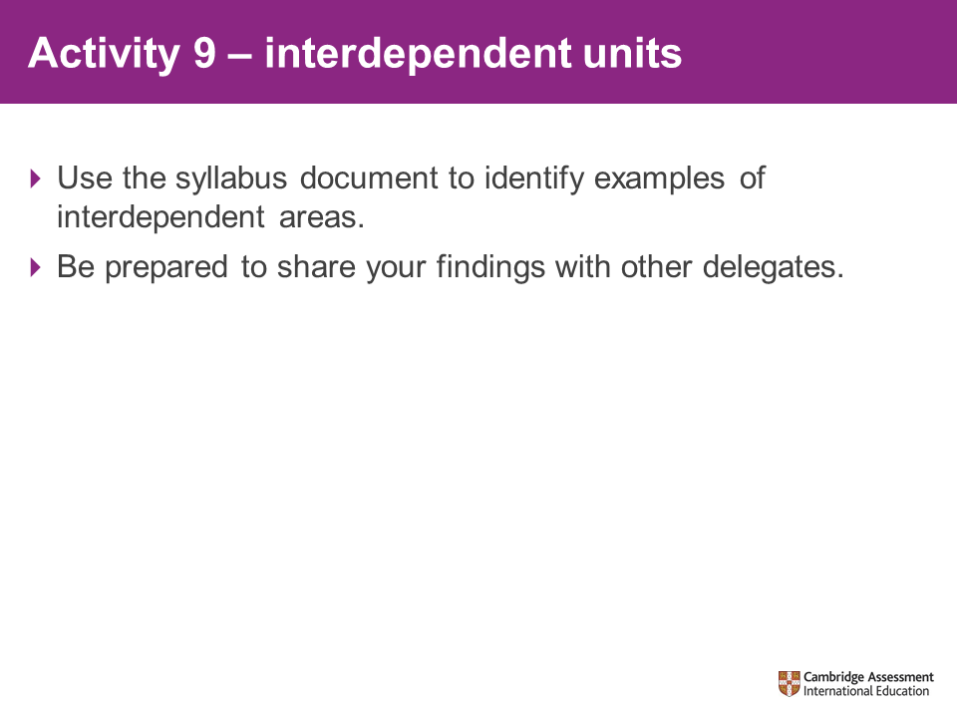
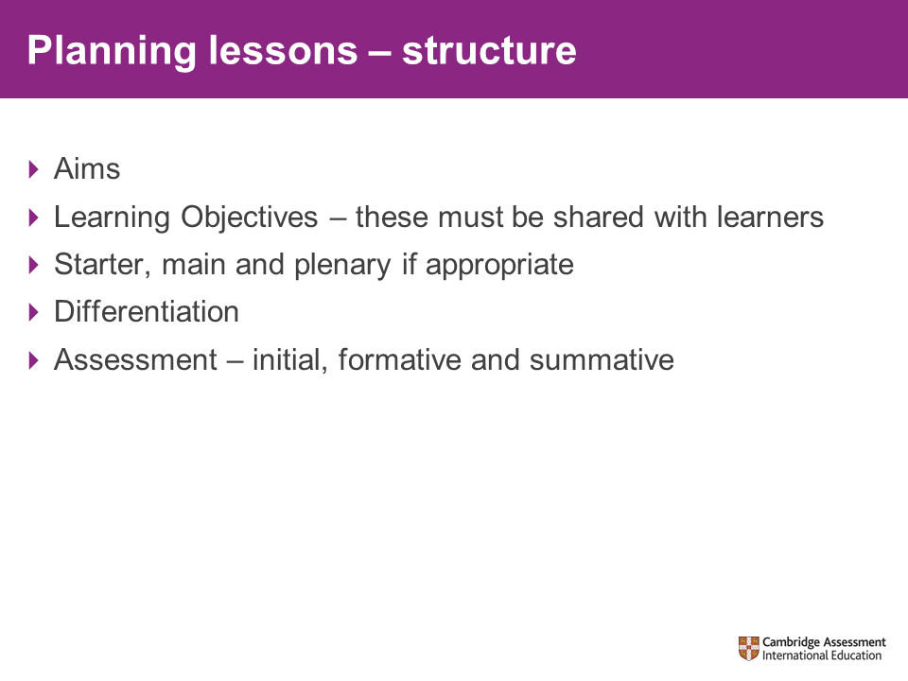 | Link the aims and objectives to the syllabus document.  Depending upon your audience, you may wish to expand upon learning objectives and sharing these with learners, three-part lesson structure, differentiation and the different types of assessment.
20-minute break
Emphasise the importance of returning punctually.
Session 5 – planning your teaching
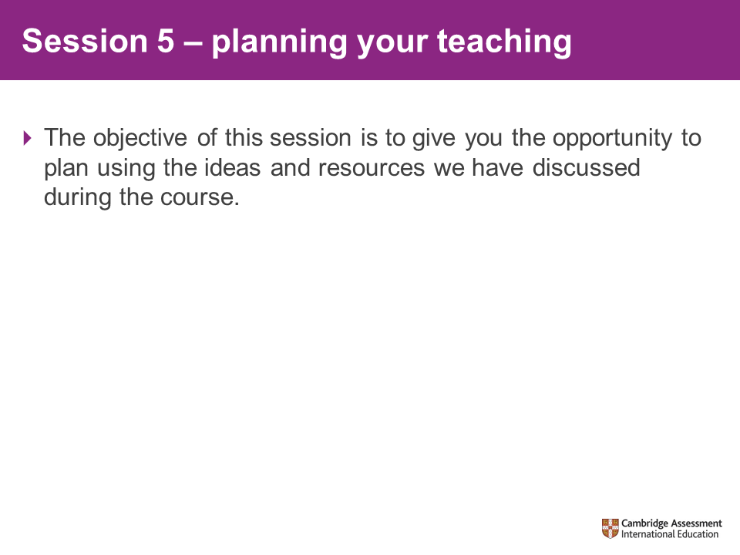 | Encourage participants to use some of the strategies they have considered over the course of the training.
Activity 10 – planning exercise
Resources needed:  - Lesson plan template  XXXX_I2_Lesson  Plan_Temp  - Example lesson plan:  XXXX_I2_Lesson_  Plan  Approximate time to complete:  - 45 minutes | Explain that we will be using the ideas seen during the previous sessions today and on Day 1 to plan a single lesson in detail.  Remind participants of some of the ideas that we have looked at in the previous sessions:  - Identifying underpinning knowledge  - Initial, formative and summative assessment  - Different teaching approaches  - Activity and resource ideas  - Use of past paper materials  - Sequencing
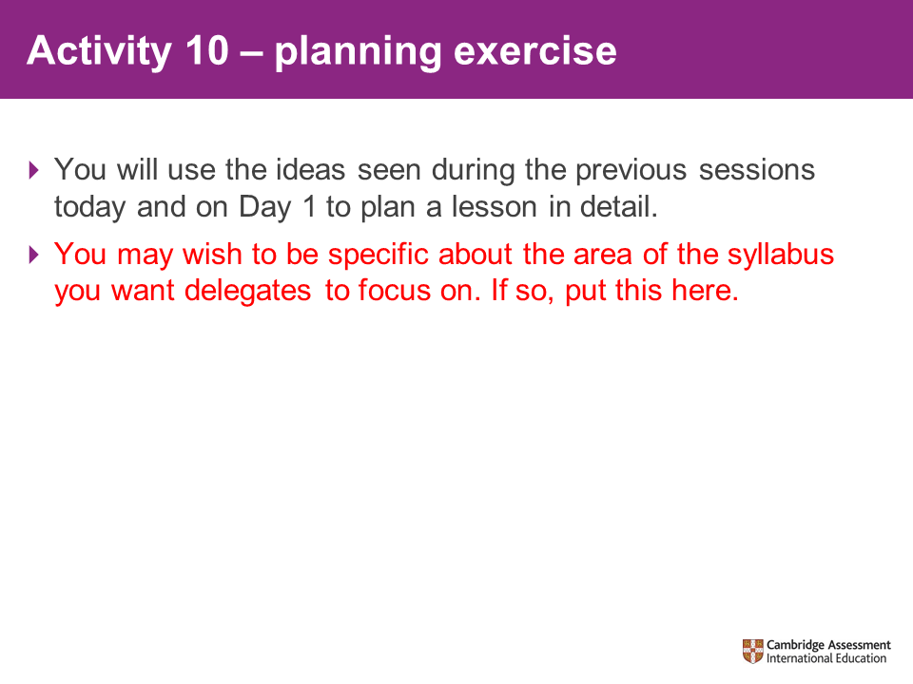
Session 6 – preparing for assessment
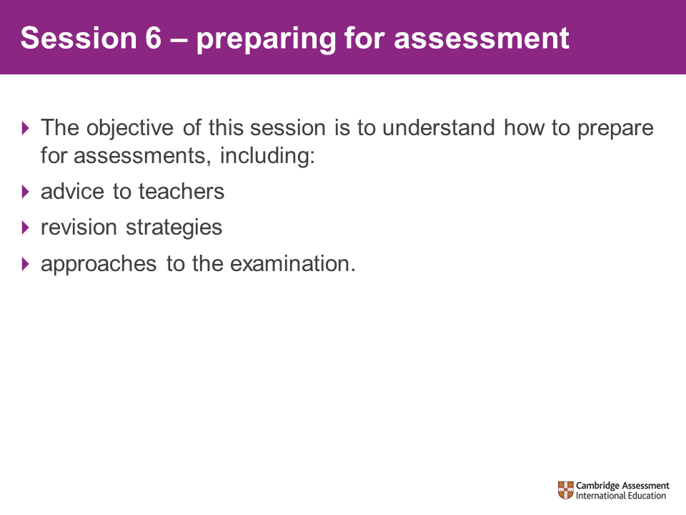 | This will be the last session of our two-day introductory training.  We are going to look at advice for learners on assessment. Before we do this, we will briefly look at some key points for staff.
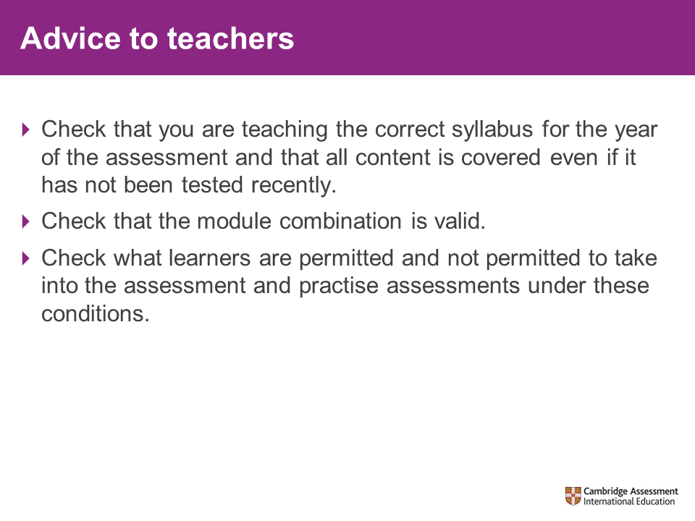 | The key points here are familiarity with the syllabus and keeping up to date with any improvements.  It is important to be familiar with the structure and content of the syllabus to ensure that you are delivering the correct module combinations, that you understand how your learners will be assessed and that you include the correct content within your teaching.  It is also crucial to keep up to date with any improvements to the syllabus. Cambridge International publishes new/revised syllabuses in September and they usually last 3 years. A Syllabus Changes document is also published on the public website summarising the changes. Just type the syllabus code into the search field the public website and you will find all the information you need. The School Support Hub website should also be visited regularly.
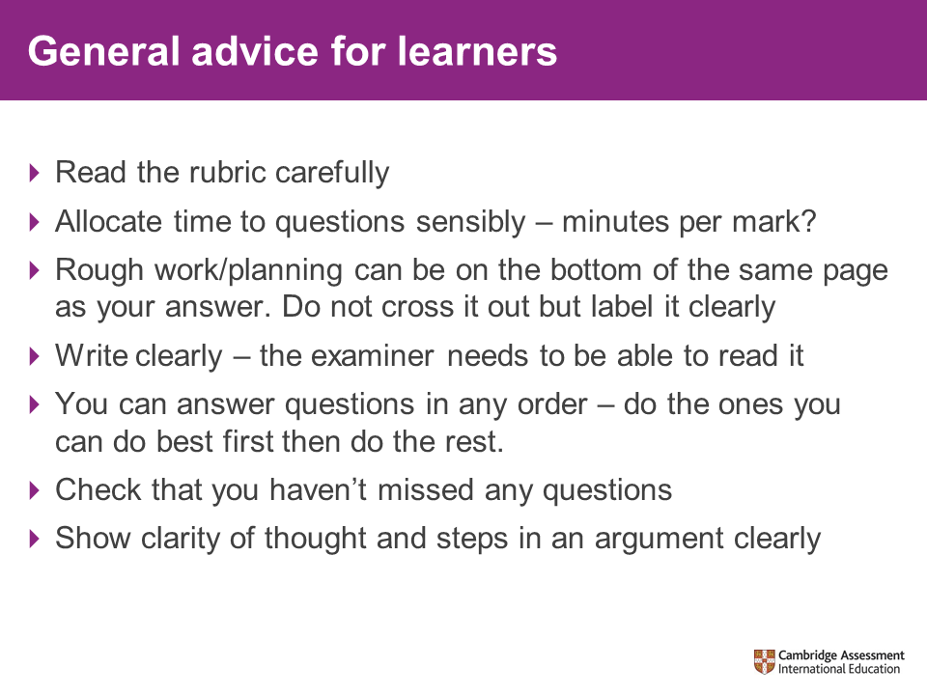 | This slide contains general good practice for exams.
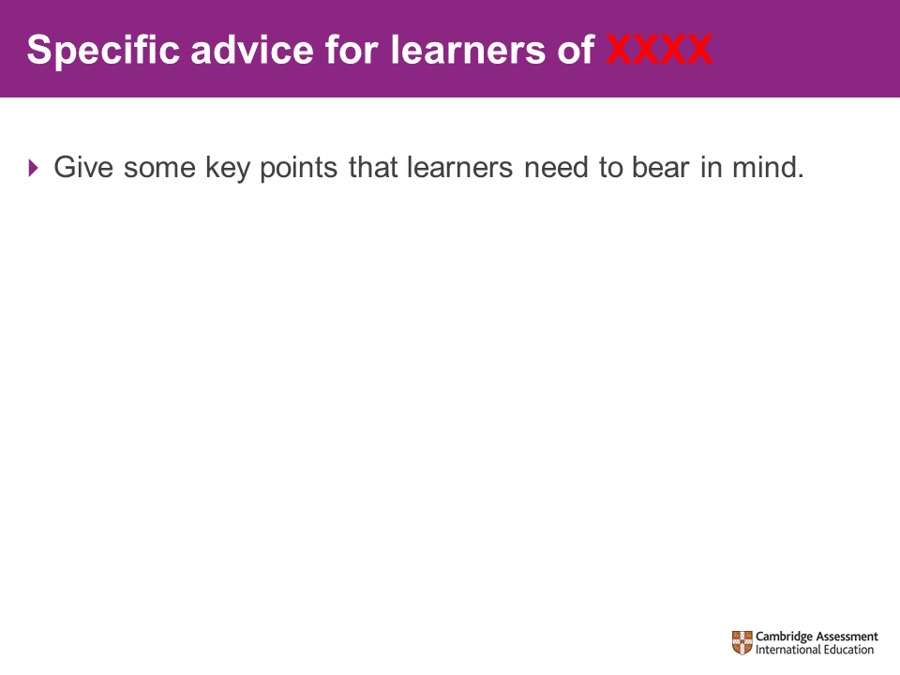 | Pack writer: you should add content/slides to the presentation to cover any of the points in the following list which apply to your syllabus.  Exams advice  - Timing advice for exams  - Common errors in exams (e.g. answering the wrong number of questions)  - Reading the rubric (pull out key points from the rubric)  - Rough work/essay plans in exams (e.g. do in the booklet, can gain marks etc.)  - What happens if they give two different attempts at a question (are both attempts marked, what mark will they get?)  - What happens if they answer too many questions?
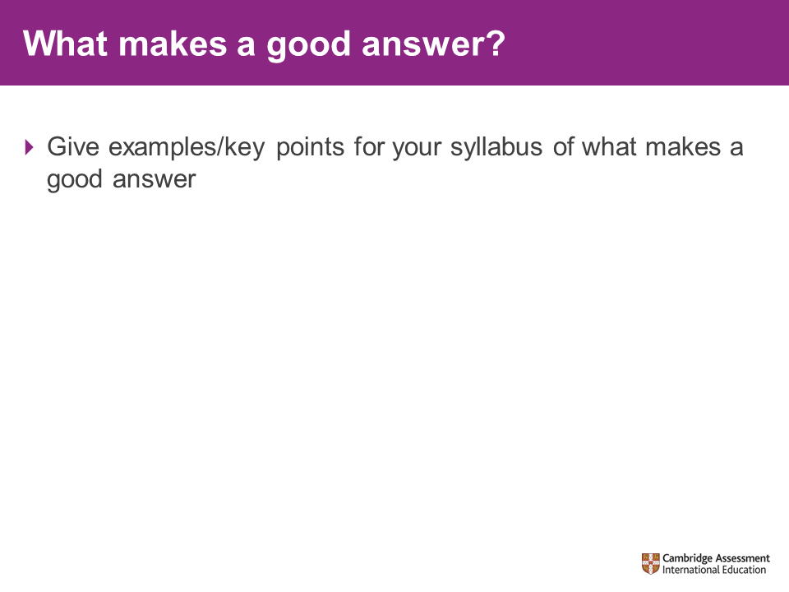 | Pack writer: summarise what makes a good exam response in your syllabus on the appropriate slide.  If available, you can use the example candidate response booklets (ECR booklets) to exemplify your points. They can be accessed on the School Support Hub.
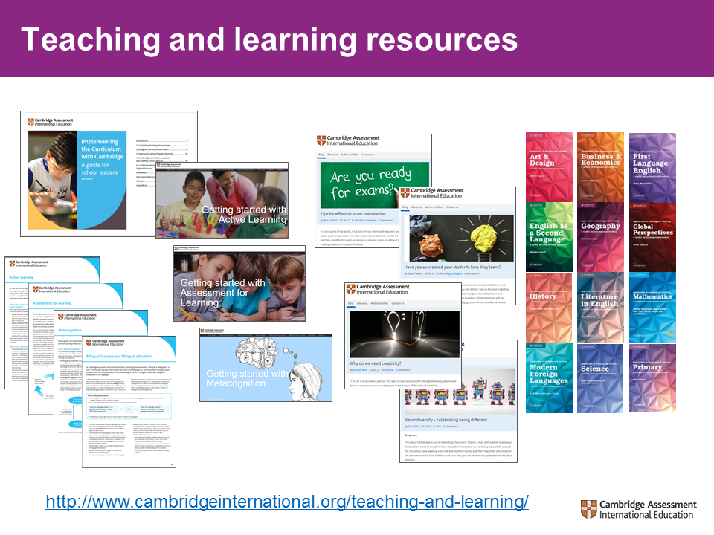 | Here you will find:  Implementing the curriculum with Cambridge – practical advice on designing, developing, implementing and evaluating your curriculum.  Developing your school with Cambridge – focusing on classroom-level activity, guidance on improving the quality of teaching and learning in your school.  Education briefs – a close look at important themes in education, including active learning, bilingual education and assessment for learning.  Getting started with… - Building on our education briefs, these guides introduce and develop areas of teaching and learning practice, and provide new ideas and approaches that link theoretical understanding with practical classroom application.
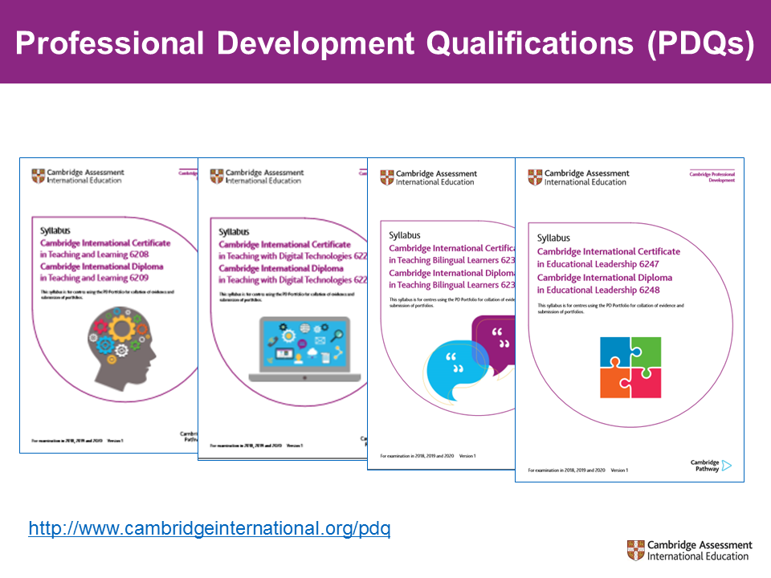 | The four syllabuses relate to the priorities of teachers, leaders and schools in the Cambridge community: Teaching and Learning,  Educational Leadership, Teaching Bilingual Learners and  Teaching with Digital Technologies.  PDQs are Cambridge Professional Development Qualifications. These are mainstream Cambridge qualifications for teachers and leaders – and they are designed to complement the learning experiences gained in Cambridge training. Programmes are delivered by a programme leader who has been trained by Cambridge and are either embedded into the life of a school or delivered by a training centre. They are for practising teachers and they fit around and draw from your day to day teaching commitments. Candidates receive guided learning from the programme leader or trainers which they then practise in their classrooms or as part of their leadership duties and then reflect upon with their mentor. They keep a portfolio of evidence which is submitted for assessment.  We have a developing centre network which means you should be able to find a PDQ programme near to you.  The qualifications are available in Teaching and Learning; Teaching with Digital Technologies; Teaching Bilingual Learners; Educational Leadership. Certificate and Diploma and all qualifications are available at Certificate level which can lead onto Diploma level.  If you are interested in knowing more about the Cambridge PDQs as either a school leader, a programme leader or a candidate then please visit our web site or email us, and we would be happy to help.
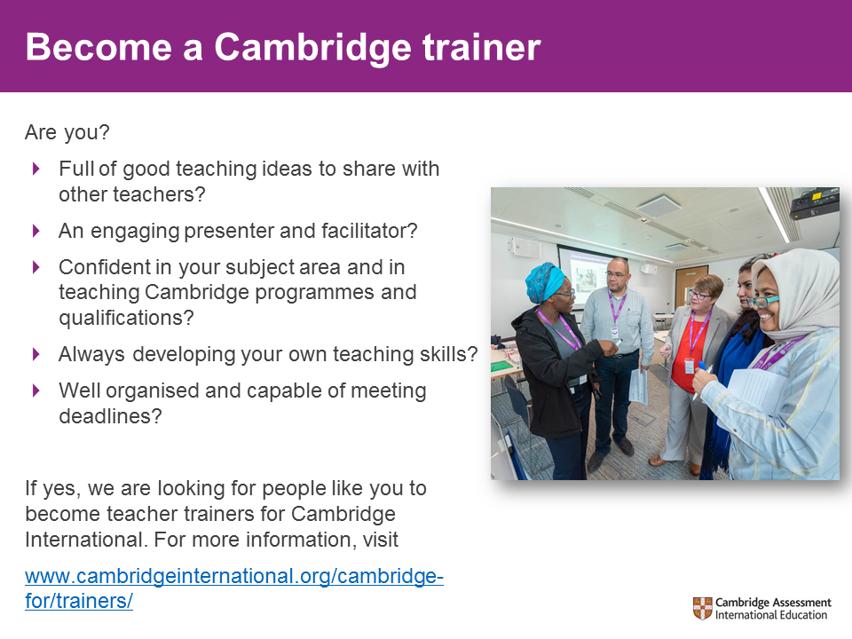 | N.B. For face to face, syllabus specific, extension level training, trainers have to also be current examiners of that syllabus.
 | We are always looking for writers with experience in the classroom, especially of modern approaches and practice. This keeps our resources, training and teacher support materials current, and relevant to our international colleagues.
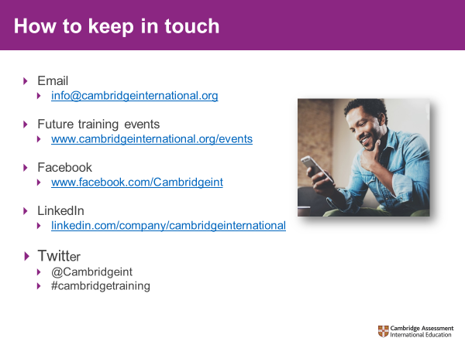 | This is a good opportunity to remind participants about the online discussion group for your subject if there is one.  Invite participants to join the Cambridge community on Facebook  For the latest news and educational debate follow us on Twitter  Join our LinkedIn group to connect with other international education professionals who are part of the global Cambridge community.
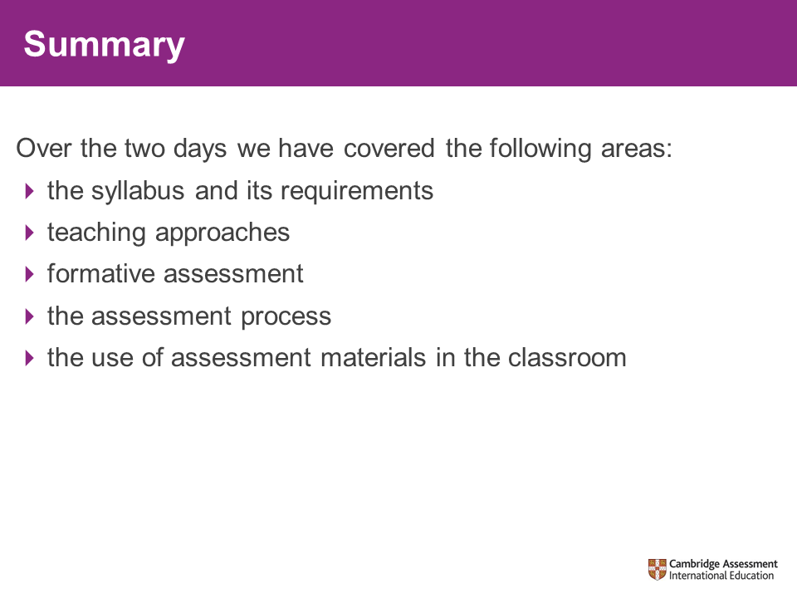  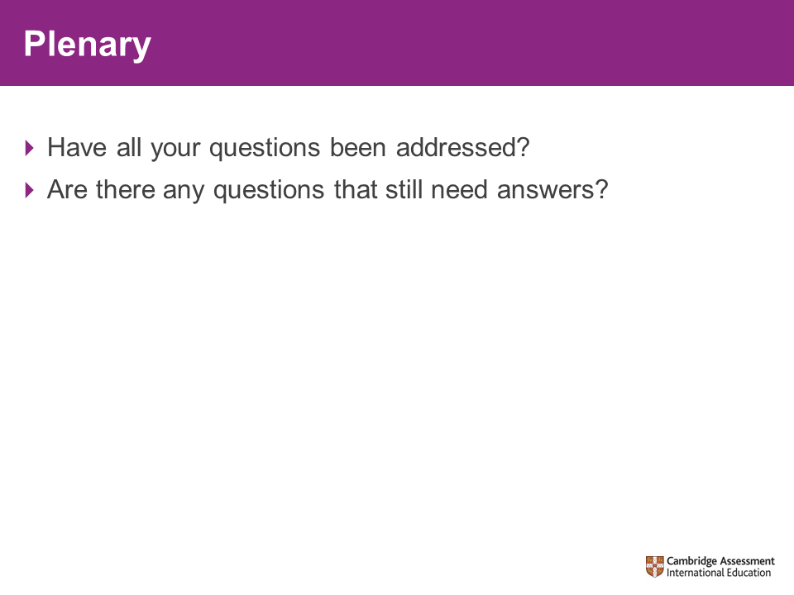 | Summarise the content of the course.  Are there any of the questions that have not been addressed? If there are then please address at this point if possible, or indicate how the answer will be made available to participants if it will be answered after the course.
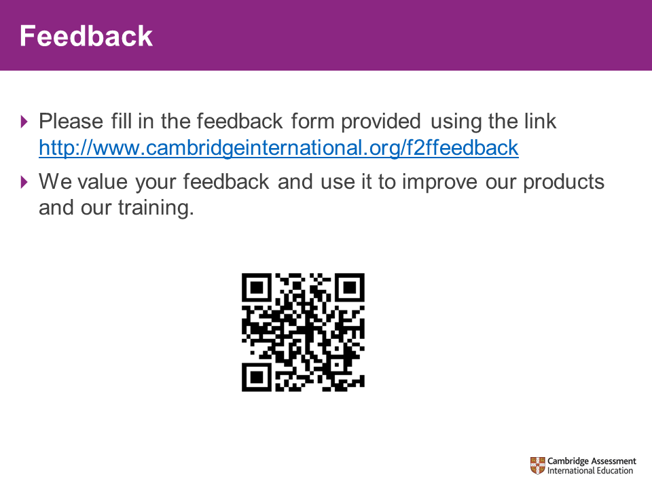 | Please allow time for and encourage all delegates to fill in the online feedback form. This can be done on laptops, smart phones or in the ICT lab of the venue.
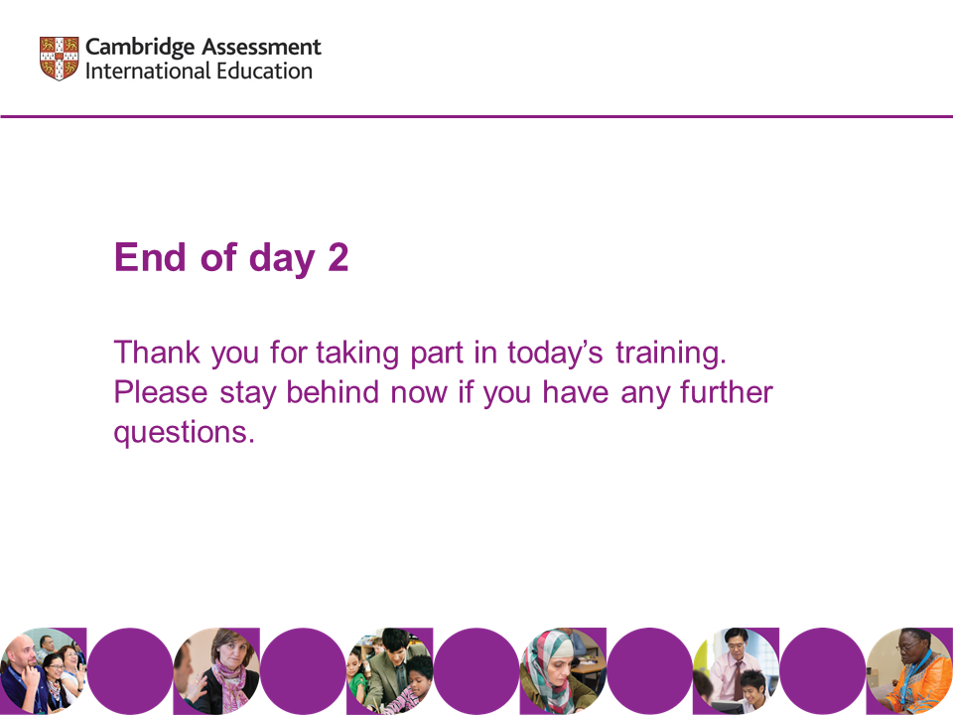 | Thanks and close.

