Printing instructions
Cambridge Code Syllabus Name 1-day Extension training

If this list is used, only the materials in section B will be printed for the delegates. During the booking process, delegates will be sent the link to the materials (in sections A and B), and will be asked to download the materials in advance. They will also be asked to bring a laptop to the training event. Spare packs (A) will be provided in case some delegates do not bring a laptop and you will be given a USB stick on which to upload the latest version of the delegate materials in case they have not downloaded a copy. You will still receive a hard copy of the materials on the day of training and we also encourage you to also save the full pack of materials onto your own USB stick and bring this to the venue. Please consider carefully which materials need to be printed. Please delete all red texts after you have filled in all sections.

Delegate pack – spare packs (A) – Please include in this section, all documents not included in section B – documents that can be viewed on screen and do not need to be written on (e.g. Syllabus, SoW, etc.)

Instructions for preparing the delegate packs:
- Please print 5 delegate packs containing all documents in list (A). These will be spares to be used in case delegates do not download their own versions.
- Each document should be printed double-sided, unless stated otherwise below.
- Each document should be stapled in the top left corner, unless stated otherwise below.
- Put the documents in the number order listed in the table below and place in the plastic folders (document number 1 on top).
- To assemble the plastic folders, see instructions on the final 2 pages of this document.

(A)

Number of copies | Document | Number of pages | Paper colour | Staple(Y/N) | Additional instructions
5 | 01. DOC NAME
Delegate pack – printed materials (B) Please include in this section, those documents that must be printed (e.g. handouts that need to be written on, slides). Please think carefully.

Instructions for preparing the delegate packs:
- Please print 1 copy per delegate of all documents in list (B). Delegates should download their own copies of all documents not in list (B).
- Please print 1 additional set of handouts for the trainer.
- Each document should be printed double-sided, unless stated below.
- Each document should be stapled in the top left corner, unless stated below.
- Put the documents in the number order listed in the table below and place in the plastic folders.
- To assemble the plastic folders, see instructions on the final 2 pages of this document.

(B)

Number of copies | Document | Number of pages | Paper colour | Stapled (Y/N) | Additional instructions
1 per delegate | 01. DOC NAME

Trainer pack

Instructions for preparing the trainer pack materials:
These documents are for the trainer only.
- Please print the documents listed in the table below, referring to the column ‘Number of copies to be printed’ to find out the quantities of each document needed.
- After they are printed, please put the documents on the trainer’s desk in separate piles (one pile for each different document).

Number of copies | Document | Number of pages | Paper colour | Stapled (Y/N) | Additional instructions
1 | 01. DOC NAME

Trainer’s desk

Instructions for preparing the trainer’s desk materials:
These materials will be given out by the trainer during the session at the relevant time.
- Please print the documents listed in the table below, referring to the column ‘Number of copies to be printed’ to find out the quantities of each document needed.
- After they are printed, please put the documents on the trainer’s desk in separate piles (one pile for each different document).

Handouts to be placed on the trainer’s desk:
Number of copies | Document | Number of pages | Paper colour | Stapled (Y/N) | Additional instructions
1 set per table | Card activity |  | White |  | Print as A5  cards, single sided.
4 copies of the same slide per table | Teaching approaches tables |  | White |  | Table 1 gets 4 copies of page 1 “Flipped learning”, Table 2 gets 4 copies of page 2 “Enquiry based learning”, etc.
1 per delegate |  |  | White
1 per delegate |  |  | White

Additional instructions

Stapling documents:

Please staple documents in the top-left hand corner of the page, unless otherwise specified.

Assembling the delegate folders:

Please note that you will need to assemble the delegate folders when you receive them. To do this, simply:
- fold all the edges
- fold the front section up to form a box
- bend the side tab and insert into the slot, corner first
- repeat on the opposite side
- insert middle tab to close the folder.

1. 2. 3.
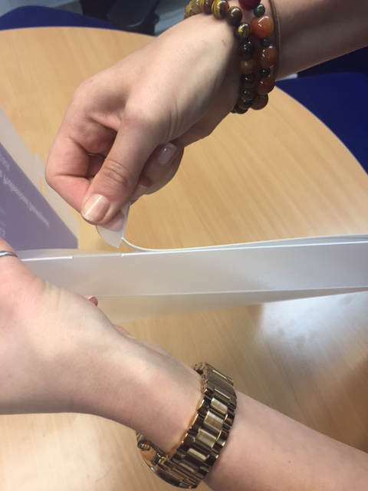
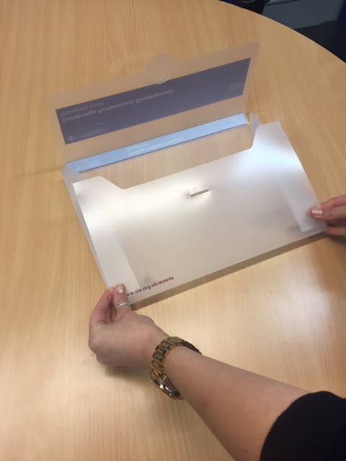
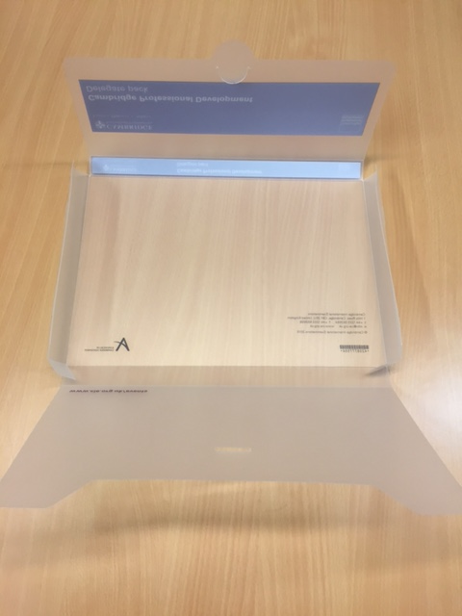

4. 5.
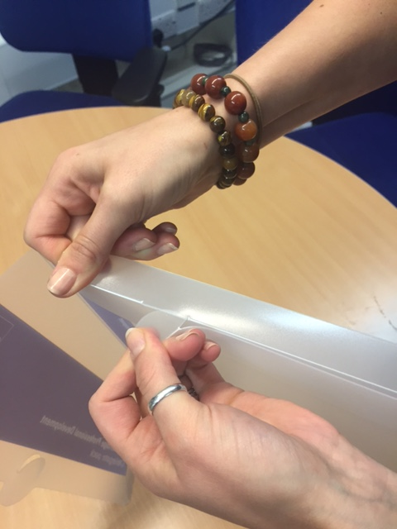
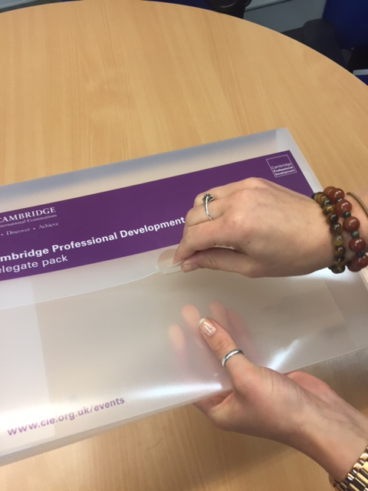

In each delegate folder please place the printed delegate pack documents listed above and one each of the following promotional materials:

- a Cambridge International notebook
- a Cambridge International pen

The training room:

Complete delegate packs should be placed on tables as shown in the photos below.
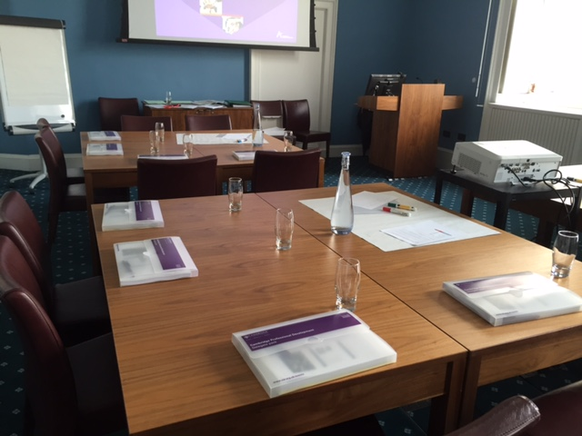
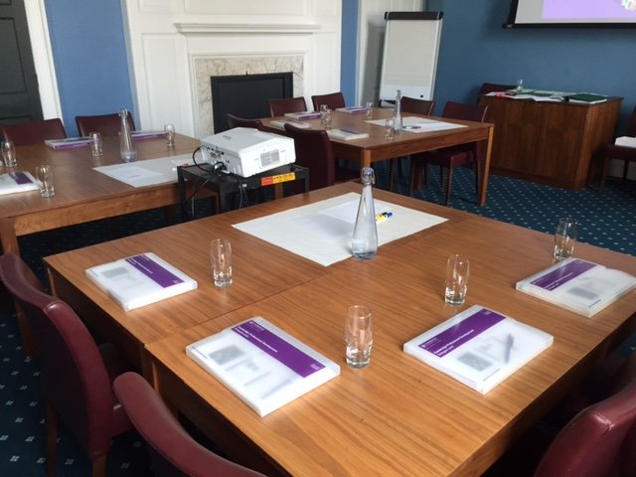
- Tables should be arranged in small groups.
- Drinking water should be available throughout the training days.
- Please also make sure that any other equipment requested by the trainer, such as marker pens, post-it notes and plain paper, is provided.

